

Reliable news for healthy living, saving money, and having fun!

********

January 2020

**Jimbo’s Floors**

**January 1**

New Year’s Day

**January 20**

Martin Luther King Day



Suzie Smith!

You are this month’s   
Mystery Winner!

We have a   
**$10.00 Starbucks   
gift card**   
reserved just for you!

Come by our store to   
claim your prize!

Inside This Issue…

* Are you this month’s Mystery Winner?
* Month at a Glance
* Surprising facts about winter weather
* Mega Trivia Contest
* Did You Know
* Time to schedule those summer vacation days
* Thank you for the Kind Words
* Client of the Month
* Find your favorite ice cream flavor in our word search puzzle

Dear Friends,

Your personal message goes here.

The personal message is important because it allows you to connect in a very personal way with your clients. This personal connection is sorely lacking in most businesses. Topic ideas:

Your hobbies

Something interesting happening this month. Wish them “Merry Christmas” or “Happy Thanksgiving.”

A thought from your heart

Appreciation for your clients and their referrals. Remind them that you will bend over backwards to provide their referrals with World Class Service.

Mention that month’s “special offer” insert

Your Friend,

Your Signature

Your Name

Month at a Glance!

Scan to see our website

*“You’ll love your new floors, or I’ll replace them free!”*

~Jim Armstrong & Mick  
[www.JimbosFloors.com](http://www.JimbosFloors.com)

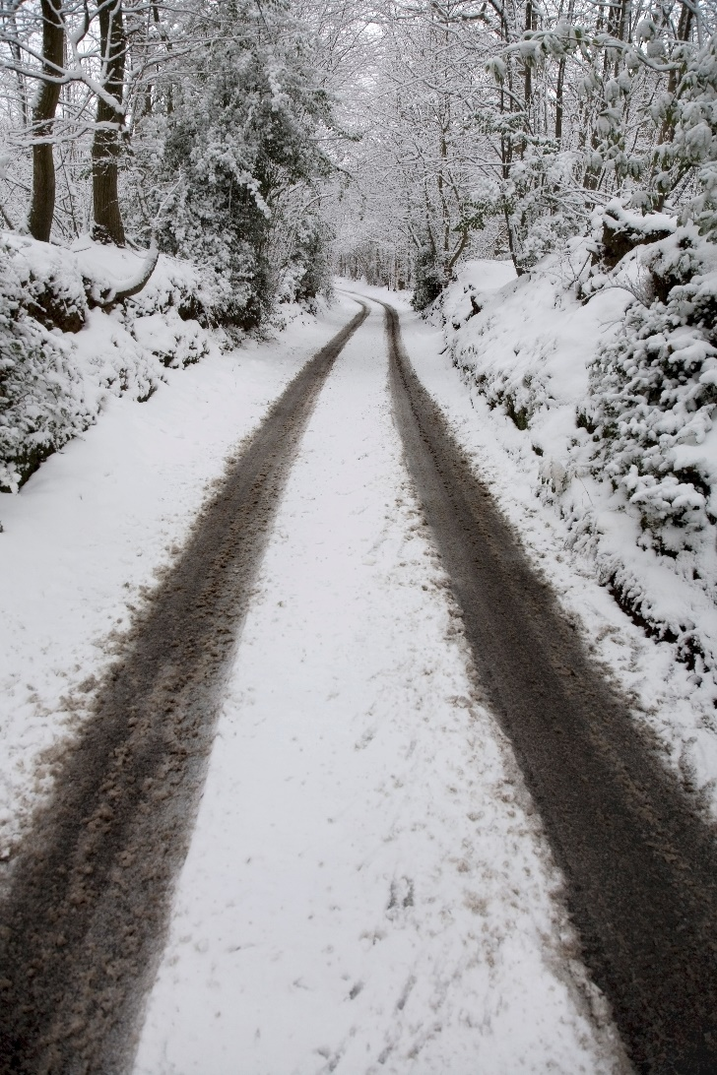

Whether you enjoy bundling up in your coziest gear or are already counting down the days until spring, here are some facts from Mental Floss about what’s happening outdoors this time of year.

#### **SNOWFLAKES COME IN ALL SIZES.** The average snowflake ranges from a size slightly smaller than a penny to the width of a human hair. But according to some unverified sources they can grow much larger. Witnesses of a snowstorm in Fort Keogh, Montana in 1887 claimed to see milk-pan sized crystals fall from the sky. If true that would make them the largest snowflakes ever spotted, at around 15 inches wide.

#### **THE SNOWIEST CITY ON EARTH IS IN JAPAN.** Aomori City in northern Japan receives more snowfall than any major city on the planet. Each year citizens are pummeled with 312 inches, or about 26 feet, of snow on average.

#### **IT SOMETIMES SNOWS WHERE YOU LEAST EXPECT IT.** Northern areas don’t have a monopoly on snowfall—the white stuff has been known to touch down everywhere from the Sahara Desert to Hawaii. Even the driest place on Earth isn’t immune. In 2011, the Atacama Desert in Chile received nearly 32 inches of snow thanks to a rare cold front from Antarctica.

#### **MORE THAN 22 MILLION TONS OF SALT ARE USED ON U.S. ROADS EACH WINTER.** That comes out to about 137 pounds of salt per person.

#### **FINALLY, SNOWFLAKES AREN’T ALWAYS UNIQUE**. There’s at least one instance of identical snowflakes in the record books. In 1988, two snowflakes collected from a Wisconsin storm were confirmed to be twins at an atmospheric research center in Colorado.

Surprising facts about winter weather

***You get a FREE Lifetime Installation Warranty on all Jimbo’s Floors!***

Buying flooring is not like buying any other piece of interior décor, such as a sofa or a lamp. Why? Because unlike other products, flooring is installed or “manufactured” in your home. This makes the installation critical.

I offer a lifetime installation warranty at Jimbo’s. You NEVER have to worry about something going wrong with the installation. If it does, I’ll fix it FREE! And I’ll do it quickly.

 - Jim Armstrong



Which side of a building do icicles most often form on?

A) North B) South

C) East D) West

To enter, email [Jimbo@JimbosFloors.com](mailto:Jimbo@JimbosFloors.com) with the subject line: “Mega Trivia Contest.” Take your best guess…your chances of winning are better than you think!

### Who Else Wants to Win

### Dinner for Two

### at the City Café!

### Take our Trivia Challenge and *you could win too!*

This month’s Mega Trivia question:

**Answer to last month’s question: A) Jingle Bells**

Congratulations to last month’s winner: **Client Name**



Time to schedule those summer vacation days



The winter months have us dreaming of summer vacations. Here are some budget-friendly summer vacation ideas for the family from the Travel Channel.

**Pittsburgh –** Known as "Kidsburgh" thanks to all the family-oriented activities in the area, Pittsburgh, Pennsylvania is an affordable and fun pick for families. Book tickets to popular attractions, like the Pennsylvania Trolley Museum and the Children’s Museum of Pittsburgh, on the VisitPittsburg website to save up to 50 percent. Take a free guided tour of the Allegheny Observatory and explore Bicycle Heaven, the world’s largest bicycle store and museum. Don’t leave Pittsburgh without taking a ride on the Duquesne Incline for one of the best cityscape views in the country.

### Florida's Nature Coast – Orlando and Miami may get the lion’s share of attention in Florida, but kids will love Florida’s Nature Coast on the lesser-explored Gulf Coast side of the Sunshine State. There you’ll find manatees, waterfalls, mermaids, even a hippo named Lu at Homosassa Springs Wildlife State Park. Three Sisters Springs on the Crystal River serves as a manatee refuge in the winter months but is a popular spot for paddling, swimming and kayaking in the summer. At Weeki Wachee Springs State Park, a magical twice-daily mermaid show will delight every member of the family.

### Albuquerque – From volcanic rocks and petroglyphs to shrubby bushes and mountains, Albuquerque, New Mexico was made to be explored by children. Start by spending the day at the ABQ BioPark. Save with discounted combo tickets, which include the zoo, aquarium and botanic garden, as well as unlimited rides on the narrow-gauge trains at the park. Join a free walking tour to learn about historic Old Town Albuquerque before popping in the American International Rattlesnake Museum. The Mesa Point Trail at Petroglyph National Monument is a must-do.

### For lots of free attractions, consider St. Louis, MO, too!

Congratulations to our client of the month,

**Susan Johnson!**

Susan is a 3rd time returning client, and she recently purchased new laminate for her kitchen and dining room. She always has a big smile on her face and is a lot of fun to work with. *Thanks, Susan!*

As always, our clients of the month receive **2 movie passes for Movies-8!**

*Watch for your name here in a coming month!*

“My new laminate floors in my kitchen and dining room are beautiful. I was treated with respect and courtesy as a single woman raising a daughter. I genuinely felt that Jim Armstrong and his staff display concern for my flooring needs and were a guiding light for me. I recommend his service to anyone looking for a supportive, positive experience.”

~Marsha Avalos, School Teacher, Yuba City

“We Recently went to Jimbo’s Floors for new tile for our bathroom, and we’re thrilled with the results! This is our third time using Jimbo’s. Jim will never make you feel uncomfortable for asking questions and he’ll do anything in his power to accommodate your needs. When you do business with Jim and the staff at Jimbo’s Floors, you will be treated like royalty. Our experience was painless and very professional. Jim is not only our flooring expert, he’s a friend. That’s how he makes you feel.”

~Marvin and Sandy Moeller, owners of Sierra Landscaping, Yuba City

Thank You for the Kind Words!



Ice cream is a favorite treat, even in winter! It’s less expensive, won’t melt, and the lines at the ice cream shop are shorter. There are great seasonal flavors like egg nog and candy cane, too.

What’s your favorite flavor? Can you find it in the puzzle?

Get a Night Out at the Movies for 2 with my

**Referral Rewards Program**

As you probably know, advertising is very expensive. Instead of paying the newspaper or another place to advertise, we’d rather reward you. So, we’ve assembled the Referral Rewards Program.

Every time you refer someone who becomes a client, we will send you a gift certificate for two passes to the **Movies-8 Cinema.**

And Hey! What’s a movie without popcorn? The gift certificate will also cover a big box of hot, buttered popcorn and sodas!

**Welcome to our new and returning clients!**

Click on the text box and Insert names

**A gigantic THANK YOU to all who referred us last month…**

Insert names

Is it ever too cold for ice cream?

**Be sure to stop by to pick out and schedule   
your new floor installation, and   
from our families to yours have a great month!**

**Your Company Name**

123 Address, Someplace, ZZ 555555

555.555.5555 Phone ⚫ 555.555.5555 Fax

email@yourcompanyname.com

**YourCompanyWebsite.com**