

Reliable news for healthy living, saving money, and having fun!



**December 25**

Christmas

**December 31**

New Year’s Eve

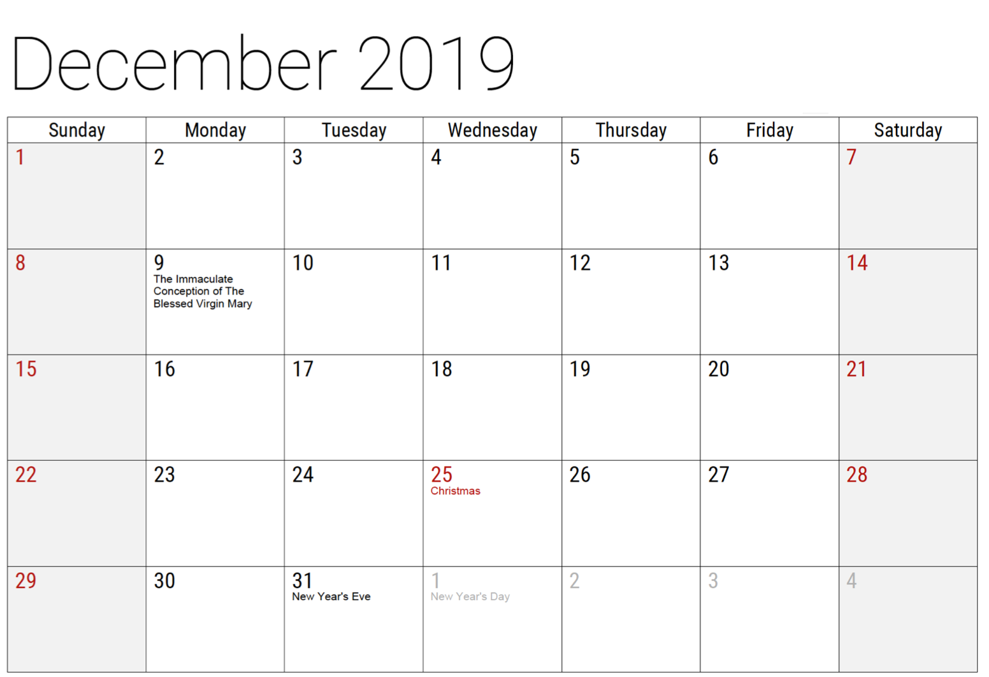

December 2019

**Jimbo’s Floors**

Suzie Smith!

You are this month’s   
Mystery Winner!

We have a   
**$10.00 Starbucks   
gift card**   
reserved just for you!

Come by our store to   
claim your prize!

Inside This Issue…

* Are you this month’s Mystery Winner?
* Month at a Glance
* Clear Clutter for a Cozy Casa
* Mega Trivia Contest
* Did you Know
* 7 Christmas Decoration Tips
* Thank you for the Kind Words
* Client of the Month
* Christmas Crossword

Dear Friends,

Your personal message goes here.

The personal message is important because it allows you to connect in a very personal way with your clients. This personal connection is sorely lacking in most businesses. Topic ideas:

Your hobbies

Something interesting happening this month. Wish them “Merry Christmas” or “Happy Thanksgiving.”

A thought from your heart

Appreciation for your clients and their referrals. Remind them that you will bend over backwards to provide their referrals with World Class Service.

Mention that month’s “special offer” insert

Your Friend,

Your Signature

Your Name

Month at a Glance!

Scan to see our website

*“You’ll love your new floors, or I’ll replace them free!”*

~Jim Armstrong & Mick  
[www.JimbosFloors.com](http://www.JimbosFloors.com)



**You are protected**

**by Jimbo’s 100%**

**Iron-Clad Triple Guarantee!**

**Guarantee #1 “Zero Regrets Guarantee!” You’ll love your new floors or I’ll replace them FREE!**

If at any time during the first 30 days after installation you decide you don’t like your new flooring for whatever reason, just let me know. I’ll replace the materials free of charge.

**Guarantee #2 Lifetime Installation Warranty**

You NEVER have to worry about something going wrong with the installation. If it does, I’ll fix it FREE!

**Guarantee #3 Installer Professionalism Guarantee**

You’ll receive the highest-quality installation in the business.

Can you name the popular Christmas song that was actually written for Thanksgiving?

A. Jingle Bells B. It Came Upon a Midnight Clear

C. Away in the Manger D. I Saw Mommy Kissing Santa Claus

To enter, email [Jimbo@JimbosFloors.com](mailto:Jimbo@JimbosFloors.com) with the subject line: “Mega Trivia Contest.” Take your best guess…your chances of winning are better than you think!

**Answer to last month’s question: A) 437 Days**

Congratulations to last month’s winner: **Client Name**

Is it always hard to find what you’re looking for in your house? Are you often late for work because you can never find your car keys?

**These tips will help save time and keep you more organized.**

**Keep things in a place that makes sense**. Drop your keys in a dish by the front door. Put anything you need to take with you by the front door- outgoing mail, your briefcase or the library books that need to be returned.

**Straighten up as you go**. Pick up the newspaper and put in the recycle bin instead of leaving it on the coffee table. Fill the dishwasher after every meal instead of once a day. Put your groceries away rather than leave them on the kitchen table.

**Finish one project before starting another**. Several unfinished projects means your house is constantly in a state of confusion and you likely will never manage to get any project completed because it’s now so overwhelming.

**Keep your bathroom tidy**. Wipe the sink and vanity top after you shave or wash your face and put your toiletries away. Doing these small things as you go keeps the bathroom looking cleaner and tidier.

**Organize your closets**. If your closet is filled to capacity, you can’t see what you have. Instead of squeezing everything into your closet, keep out of season clothes in the spare bedroom closet. Keep shoes in boxes or shoe racks. Donate any garments that no longer fit or if you haven’t worn them in the past season.

**Don’t hang onto things** you can’t use anymore because there is someone out there who will be grateful to have it.

Now, enjoy your clean, cozy casa!



### Who Else Wants to Win

### Dinner for Two

### at the City Café!

### Take our Trivia Challenge and *you could win too!*

This month’s Mega Trivia question:

Clear Clutter for a Cozy Casa

Decorating for Christmas is one of the best things about the holidays. When decorating your home, you want the decor to reflect your own personal style while keeping the Christmas tradition always present. A few tips can help make this holiday decorating season even brighter.

**Decoration Tip #1: Lights Out**

Some Christmas light strands burn with the exception of a burned-out light, otherwise it can be a real headache to find the faulty bulb. Consider investing in a light tester, which will check each individual light and detect the one that needs replacing.

**Decoration Tip #2: Add a personal touch**

If you hang Christmas stockings, consider personalizing them with your name, your spouse’s name and those of your children. Don’t forget to add Fido’s name on a stocking.

**Decoration Tip #3: Pucker up**

Decorate your home with mistletoe, a great holiday tradition. A mistletoe is always a nice touch and especially if you just need one more reason to smooch.

**Decoration Tip #4: Working with wreaths**

A green wreath on the front door of your home will add a festive touch. Don’t forget a red bow for a brightening touch! If you want to add wreaths to the windows in your home, consider purchasing a 2-part magnetic wreath hanger. One part goes on the inside of your window and the piece with the hook will go on the outside.

**Decoration Tip #5: A perfect fit**

When choosing a Christmas tree, make sure to measure the preferred location from side to side and from floor to ceiling. You will want to make

sure that perfect tree fits when you bring it home.

**Decoration Tip #6: Shop smart**

Make sure that all electric decorations are UL listed to ensure that they have been tested for quality and safety. Don’t forget to unplug everything before you leave home or go to bed at night.

**Decoration Tip #7: It’s all about tradition**

It’s nice to start a family tradition by decorating your tree on a certain day each year. Perhaps after Thanksgiving dinner, (or dare we say, after Halloween??) the whole family can spend the evening dressing their home for Santa.

7 Christmas Decoration Tips



Congratulations to our client of the month,

**Susan Johnson!**

Susan is a 3rd time returning client, and she recently purchased new laminate for her kitchen and dining room. She always has a big smile on her face and is a lot of fun to work with. *Thanks, Susan!*

As always, our clients of the month receive **2 movie passes for Movies-8!**

*Watch for your name here in a coming month!*

“My new laminate floors in my kitchen and dining room are beautiful. I was treated with respect and courtesy as a single woman raising a daughter. I genuinely felt that Jim Armstrong and his staff display concern for my flooring needs and were a guiding light for me. I recommend his service to anyone looking for a supportive, positive experience.”

~Marsha Avalos, School Teacher, Yuba City

“We Recently went to Jimbo’s Floors for new tile for our bathroom, and we’re thrilled with the results! This is our third time using Jimbo’s. Jim will never make you feel uncomfortable for asking questions and he’ll do anything in his power to accommodate your needs. When you do business with Jim and the staff at Jimbo’s Floors, you will be treated like royalty. Our experience was painless and very professional. Jim is not only our flooring expert, he’s a friend. That’s how he makes you feel.”

~Marvin and Sandy Moeller, owners of Sierra Landscaping, Yuba City

Thank You for the Kind Words!



**Be sure to stop by to pick out and schedule   
your new floor installation, and   
from our families to yours have a great month!**

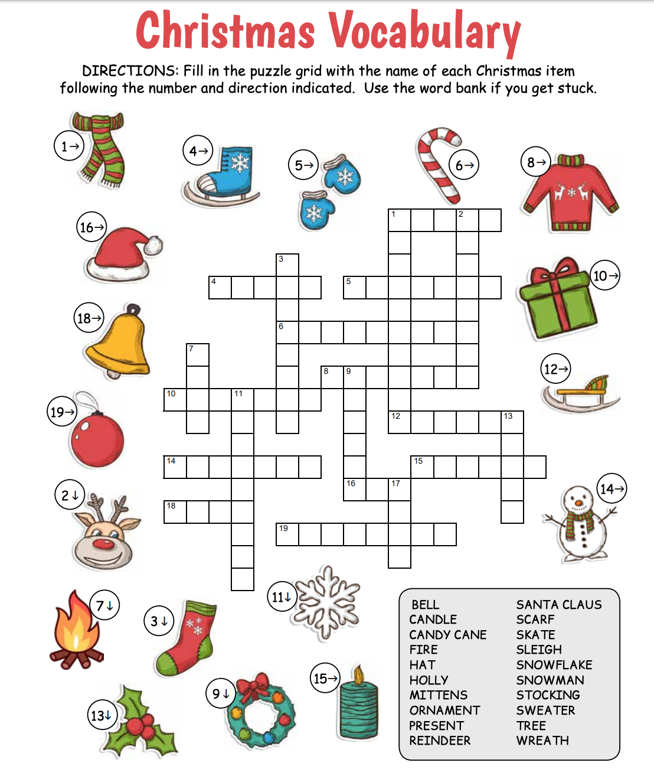

Get a Night Out at the Movies for 2 with my

**Referral Rewards Program**

As you probably know, advertising is very expensive. Instead of paying the newspaper or another place to advertise, we’d rather reward you. So, we’ve assembled the Referral Rewards Program.

Every time you refer someone who becomes a client, we will send you a gift certificate for two passes to the **Movies-8 Cinema.**

And Hey! What’s a movie without popcorn? The gift certificate will also cover a big box of hot, buttered popcorn and sodas!

**Welcome to our new and returning clients!**

Click on the text box and Insert names

**A gigantic THANK YOU to all who referred us last month…**

Insert names

Christmas Crossword

**Your Company Name**

123 Address, Someplace, ZZ 555555

555.555.5555 Phone ⚫ 555.555.5555 Fax

email@yourcompanyname.com

**YourCompanyWebsite.com**