

Reliable news for healthy living, saving money, and having fun!

****

**November 1**

All Saint’s Day

**November 11**

Veteran’s Day (USA)

**November 28**

Thanksgiving   
(US)

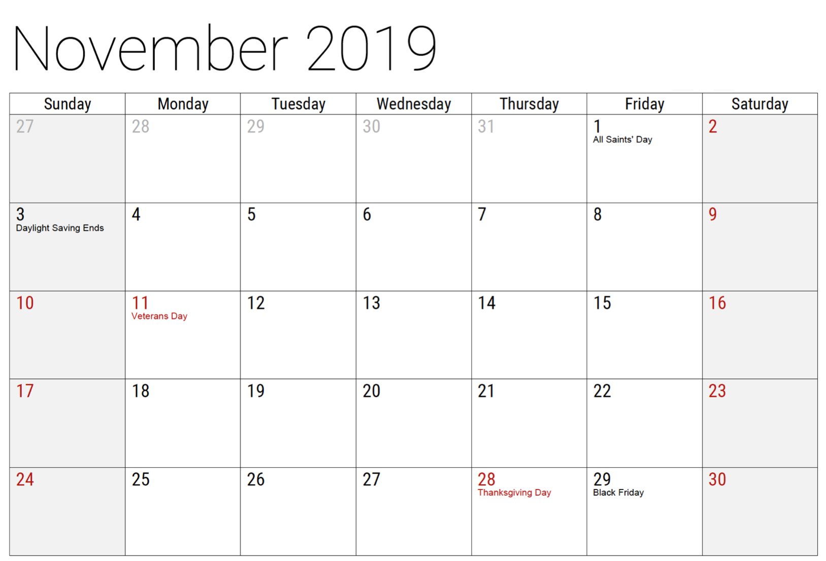

November 2019

**Jimbo’s Floors**

Suzie Smith!

You are this month’s   
Mystery Winner!

We have a   
**$10.00 Starbucks   
gift card**   
reserved just for you!

Come by our store to   
claim your prize!

Inside This Issue…

* Are you this month’s Mystery Winner?
* Month at a Glance
* Get Supercharged With Kindness Motivation Tips
* Mega Trivia Contest
* Did you Know
* How To Choose A Dog Trainer
* Thank you for the Kind Words
* Client of the Month
* Have You Ever Played Sudoku?

Dear Friends,

Your personal message goes here.

The personal message is important because it allows you to connect in a very personal way with your clients. This personal connection is sorely lacking in most businesses. Topic ideas:

Your hobbies

Something interesting happening this month. Wish them “Merry Christmas” or “Happy Thanksgiving.”

A thought from your heart

Appreciation for your clients and their referrals. Remind them that you will bend over backwards to provide their referrals with World Class Service.

Mention that month’s “special offer” insert

Your Friend,

Your Signature

Your Name

Month at a Glance!

Scan to see our website

*“You’ll love your new floors, or I’ll replace them free!”*

~Jim Armstrong & Mick  
[www.JimbosFloors.com](http://www.JimbosFloors.com)



What is the longest continuous time a human has spent in space? (Plus or minus 20 days).

A) 437 Days B) 21 Days

C) 1,460 Days D) 365 Days

To enter, email [Jimbo@JimbosFloors.com](mailto:Jimbo@JimbosFloors.com) with the subject line: “Mega Trivia Contest.” Take your best guess…your chances of winning are better than you think!

**Answer to last month’s question: C) Fortnite**

Congratulations to last month’s winner: **Client Name**

Are you looking for ideas or motivation tips to make a difference in your life or for someone else’s life?

Are you like most everyone and just don’t have much time?

Can you perform random acts of kindness every day?

Honestly, it doesn’t take much time to brighten someone’s life. A few minutes a day can make a difference to a person or a family. Just some kindness and the evidence that someone cares about them can turn their world around.

**These five motivation tips** from the E-book, “*101 Ways to Change the World*”, don’t take much time, so begin to make a difference today! You’ll feel better — and so will the recipient of your kindness.

**1. Send at least one e-mail a day telling someone:**

* How much they are appreciated
* Thanking them for something they did for you
* Telling them something you like about them

You can also send beautiful, encouraging e-cards, by visiting www.TogetherWeCanChangeTheWorld.com

You’ll find the right e-card for every occasion – these are not your usual, everyday e-cards!

**2. Send a note of appreciation to your local police department or Fire Station** to encourage the people who make a difference in everyone’s lives. This doesn’t happen nearly enough for these people who put their lives on the line for all of us every day.

**3. Put a Thank You note and a cookie in the box for your Paper Delivery person.** Can you imagine the last time they were shown a kindness for doing their job?

**4. Have everyone in your family (even if it’s just you) drop all their loose change in a large glass jar you keep on the counter,** then every six months decide where to send it.

Make a family ritual out of the event and make a difference in someone’s life almost effortlessly.

**5. Buy a few extra items at your grocery store and drop them by your local homeless shelter or food bank.** You’ll make huge a difference, simply by adding a handful of extra items and a few minutes to your shopping.

Here at Jimbo’s Floors

we use a special diagnostic tool called the Design Audit™.

Our free Design Audit™ is carefully crafted to take the headache out of shopping for new floors. A simple series of questions let my expert floor consultants narrow down the thousands of options to the two or three that exactly match your unique situation.

They’ll provide you with a written, customized “maintenance” plan with their professional recommendations for getting the longest life and beauty out of your floor.

Call or visit us today for your FREE Design Audit!™



### Who Else Wants to Win

### Dinner for Two

### at the City Café!

### Take our Trivia Challenge and *you could win too!*

This month’s Mega Trivia question:

Get Supercharged with Kindness Motivation Tips



How to choose a dog trainer



With so many dog trainers out there, it can be hard trying to choose the best one for your dog. Trying to determine which dog trainer is the best qualified to train your dog can be a difficult task.

The American Dog Trainers Network recommends the following criteria for choosing a dog trainer for your dog:

**Reputation:** As with any service-based business, reviews are important! Get recommendations from your vet, friends, family members, etc. in addition to online reviews.

**Experience**: Years of experience and areas of expertise are just a couple of things to look for. A good, professional dog trainer won’t hesitate to answer your questions, so be prepared to ask a lot of them.

**Love for dogs:** You’ll know a great trainer by his or her joy of living and working with dogs.

**Extensive behavioral knowledge:** Dedicated trainers keep up-to-date on all of the latest training methods by attending dog training and animal behavioral courses, conferences, seminars, workshops, etc. whenever possible. Make sure you inquire about any recent educational courses that the trainer has attended.

**Teaching and communication skills:** Dog trainers that have good teaching and communication skills make the learning process easier, quicker and more enjoyable for the you and for the dogs.

**Affiliation with reputable organizations:** You can always tell a good dog trainer by the organizations, associations and clubs that he or she is affiliated with.

**Ethics or profit?:** You should find out what motivates a potential dog trainer. Is he or she in it strictly for the money, or for their love of dogs?

Unless a dog trainer comes recommended by one or more reputable source, it really is a case of buyer beware. Anyone can call themselves a dog trainer. Do your homework when choosing a dog trainer for your dog. Choosing the right trainer can make your life with our dog much more enjoyable!

Congratulations to our client of the month,

**Susan Johnson!**

Susan is a 3rd time returning client, and she recently purchased new laminate for her kitchen and dining room. She always has a big smile on her face and is a lot of fun to work with. *Thanks, Susan!*

As always, our clients of the month receive **2 movie passes for Movies-8!**

*Watch for your name here in a coming month!*

“My new laminate floors in my kitchen and dining room are beautiful. I was treated with respect and courtesy as a single woman raising a daughter. I genuinely felt that Jim Armstrong and his staff display concern for my flooring needs and were a guiding light for me. I recommend his service to anyone looking for a supportive, positive experience.”

~Marsha Avalos, School Teacher, Yuba City

“We Recently went to Jimbo’s Floors for new tile for our bathroom, and we’re thrilled with the results! This is our third time using Jimbo’s. Jim will never make you feel uncomfortable for asking questions and he’ll do anything in his power to accommodate your needs. When you do business with Jim and the staff at Jimbo’s Floors, you will be treated like royalty. Our experience was painless and very professional. Jim is not only our flooring expert, he’s a friend. That’s how he makes you feel.”

~Marvin and Sandy Moeller, owners of Sierra Landscaping, Yuba City

Thank You for the Kind Words!



The Classic Sudoku is a number placing puzzle based on a 9X9 grid with several given numbers. The object is to place the numbers 1 to 9 in the empty squares **so that each row, each column, and each 3X3 box contains the same number only once**.

Sudoku puzzles come in endless number combinations and range from very easy to extremely difficult taking anything from five minutes to several hours to solve. They also come in many variants, each looking differently and each offering a unique twist of brain challenging logic.

However, make one mistake in any area of any of the variants and you’ll find yourself stuck later on as you get closer to the solution…

Try this puzzle and see if you can solve it!

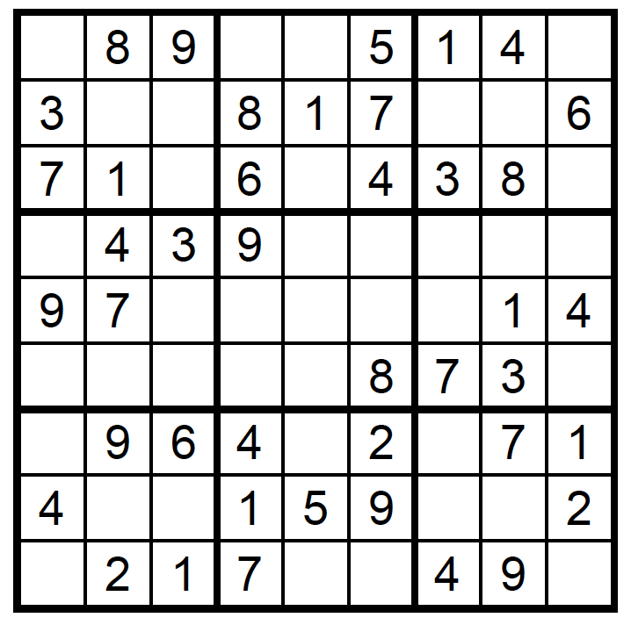

Get a Night Out at the Movies for 2 with my

**Referral Rewards Program**

As you probably know, advertising is very expensive. Instead of paying the newspaper or another place to advertise, we’d rather reward you. So, we’ve assembled the Referral Rewards Program.

Every time you refer someone who becomes a client, we will send you a gift certificate for two passes to the **Movies-8 Cinema.**

And Hey! What’s a movie without popcorn? The gift certificate will also cover a big box of hot, buttered popcorn and sodas!

**Welcome to our new and returning clients!**

Click on the text box and Insert names

**A gigantic THANK YOU to all who referred us last month…**

Insert names

Have you ever played Sudoku?

**Be sure to stop by to pick out and schedule   
your new floor installation, and   
from our families to yours have a great month!**

**Your Company Name**

123 Address, Someplace, ZZ 555555

555.555.5555 Phone ⚫ 555.555.5555 Fax

email@yourcompanyname.com

**YourCompanyWebsite.com**