

Reliable news for healthy living, saving money, and having fun!

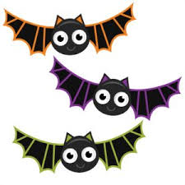****

**October 14**

Columbus Day (US)

**October 14**

Thanksgiving (CA)

**October 19**

Sweetest Day

**October 31**

Halloween

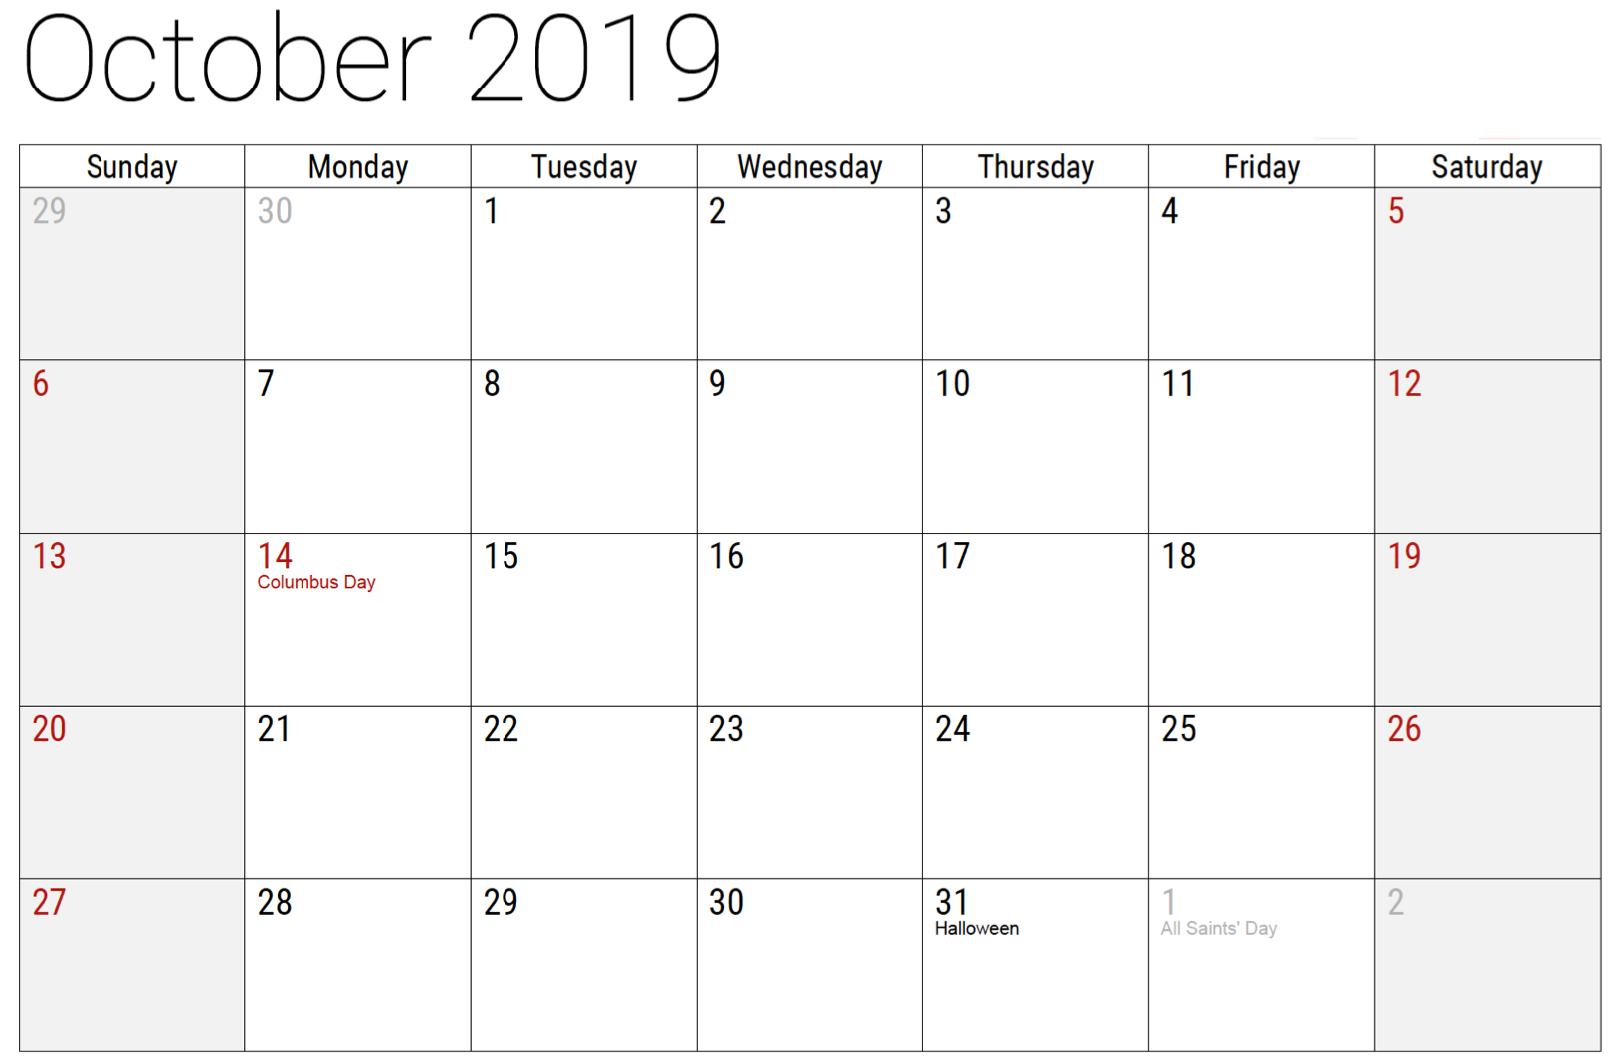

October 2019

**Jimbo’s Floors**

Suzie Smith!

You are this month’s   
Mystery Winner!

We have a   
**$10.00 Starbucks   
gift card**   
reserved just for you!

Come by our store to   
claim your prize!

Inside This Issue…

* Are you this month’s Mystery Winner?
* Month at a Glance
* YUM! It’s Pizza Month!
* Mega Trivia Contest
* Did you Know
* Taming Your Variable Expenses
* Thank you for the Kind Words
* Client of the Month
* Halloween Word Search

Dear Friends,

Your personal message goes here.

The personal message is important because it allows you to connect in a very personal way with your clients. This personal connection is sorely lacking in most businesses. Topic ideas:

Your hobbies

Something interesting happening this month. Wish them “Merry Christmas” or “Happy Thanksgiving.”

A thought from your heart

Appreciation for your clients and their referrals. Remind them that you will bend over backwards to provide their referrals with World Class Service.

Mention that month’s “special offer” insert

Your Friend,

Your Signature

Your Name

Month at a Glance!

Scan to see our website

*“You’ll love your new floors, or I’ll replace them free!”*

~Jim Armstrong & Mick  
[www.JimbosFloors.com](http://www.JimbosFloors.com)



Fall foliage in New England provides a showcase for Mother Nature. Perhaps nowhere else in America, and maybe even the world, are the fall colors as stunning and spectacular as October in New England.

Fall foliage in New England really begins in August. The shortening daylight hours trigger the deciduous trees to begin the process of shedding their leaves. It happens all around North America. But in New England it results in a display of special landscapes painted with fiery autumn colors.

**Why is fall foliage in New England so different and special?**

It’s a factor of many things but mostly an abundance of different types of deciduous trees, warm autumn days, and cool – but not freezing – nights. When these and a few other conditions are all mixed in the right proportions, then you get the world-famous stunning shades of reds, yellows, oranges, and browns on the hills and mountain sides of New England.

Between mid-September to late-October, visitors flock to New England to see the fall foliage. Many take special bus tours or even train rides. But most take to the road and **these two scenic drives offer some of the best autumn views available from anywhere on the planet**.

(Photo credit Don Graham)

In Massachusetts the most popular fall foliage scenic drives are along the famous **Mohawk Trail**, and the area known as The Berkshires. The Mohawk trail rolls out through the northwestern part of the state on route 2, and winds through the hills and mountains of the Berkshires, touching picturesque towns like Williamstown, Deerfield, Shelbourne, Colrain, Charlemont, and Shelburne Falls. The road follows an ancient foot path used to move between Massachusetts and New York by Native Americans.

Mount Greylock, the highest point in The Berkshires and Massachusetts, offers stunning views of the surrounding area and Mohawk Trail.

**The White Mountain National Forest** is home to many wonderful scenic drives but the most popular – and rightly so – has to be the 34-mile Kancamagus Scenic Highway that runs along route 112 from Conway to White Mountains Visitor Center in Lincoln. This drive is considered by many to be the top fall foliage New England scenic drive.

You’ll see beautiful forests ablaze with autumn colors and plenty of photo opportunities with walks along gorges and streams, and with breathtaking views of the highest mountains in the Presidential Range.



**When you buy floors**

**from us, you are**

**protected by our Installer Professionalism guarantee!**

It’s part of our part of Jimbo’s Floors 100% Iron-Clad Triple Guarantee.

Our installers are neat, clean, well-groomed, well-spoken and professional. They are trained and certified. They are guests in your home and they conduct themselves as such. They respect your home by using wall and corner guards, shoe covers and drop cloths.

You’ll receive the highest-quality installation in the business. And after they’re finished, they will leave your home as neat and clean as when they arrived!

What was the most popular Halloween costume in 2018?

A) Voldemort B) Witch

C) Fortnite D) Ghost

To enter, email [Jimbo@JimbosFloors.com](mailto:Jimbo@JimbosFloors.com) with the subject line: “Mega Trivia Contest.” Take your best guess…your chances of winning are better than you think!

### Who Else Wants to Win

### Dinner for Two

### at the City Café!

### Take our Trivia Challenge and *you could win too!*

This month’s Mega Trivia question:

**Answer to last month’s question: D) “Man” From Bambi**

Congratulations to last month’s winner: **Client Name**

2 Of The Best Fall Foliage Scenic Drives in New England



Last issue we looked at *fixed expenses*. Now let’s turn our attention to the discretionary part of the budget.

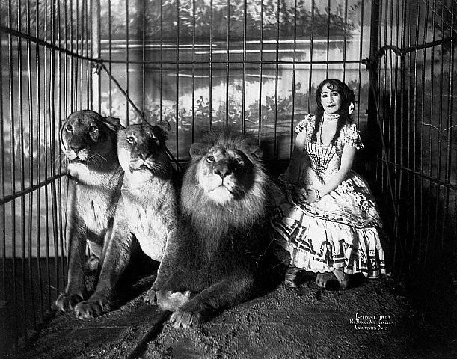

***Food*** –the largest component of our “discretionary” spending, over which we have great control. By making a few simple changes, this lion can be tamed.

1. Keep track of your spending for a week, dividing it into eat out, take out and cook at home.

1. Shift the proportions so you’re cooking at home more.
2. Then shift again, from heat-up meals to cook from scratch.
3. Plan your meals ahead and shop only once or twice a week – no running to the store twice a day.

At the end of three months, your spending on food will have dropped substantially, while the benefits to your health increase.

***Clothing*** – we all need a clothing allowance, but we don’t need sixty ties or forty pairs of shoes. Here are some suggestions:

1. Clean out your closets when the seasons change
2. Throw out worn items, donate the slightly worn, place top notch items you know you won’t wear with a consignment shop.
3. Budget for the inevitable wear and tear: shoes, socks and underwear.
4. Treat yourself to the occasional item that catches your eye, but don’t go overboard.

***Entertainment*** – going out for an evening is one of the joys of civilized society – it’s been around since we were visiting the neighbors two caves over. But there is such a thing as overdoing it. Some simple alternatives:

1. Host a potluck supper – you may want to give general suggestions to avoid having to face a table full of potato salad.
2. Suggest a traveling party, where your potluck proceeds from appetizer at one home to salad at the next, and so forth.
3. Watch the game or movie as a group, with made at home snacks.
4. Turn off the media and have an old school board game challenge!

Thank You for the Kind Words!

“My new laminate floors in my kitchen and dining room are beautiful. I was treated with respect and courtesy as a single woman raising a daughter. I genuinely felt that Jim Armstrong and his staff display concern for my flooring needs and were a guiding light for me. I recommend his service to anyone looking for a supportive, positive experience.”

~Marsha Avalos, School Teacher, Yuba City

“We Recently went to Jimbo’s Floors for new tile for our bathroom, and we’re thrilled with the results! This is our third time using Jimbo’s. Jim will never make you feel uncomfortable for asking questions and he’ll do anything in his power to accommodate your needs. When you do business with Jim and the staff at Jimbo’s Floors, you will be treated like royalty. Our experience was painless and very professional. Jim is not only our flooring expert, he’s a friend. That’s how he makes you feel.”

~Marvin and Sandy Moeller, owners of Sierra Landscaping, Yuba City

Congratulations to our client of the month,

**Susan Johnson!**

Susan is a 3rd time returning client, and she recently purchased new laminate for her kitchen and dining room. She always has a big smile on her face and is a lot of fun to work with. *Thanks, Susan!*

As always, our clients of the month receive **2 movie passes for Movies-8!**

*Watch for your name here in a coming month!*

Taming Your Variable Expenses



**Your Company Name**

123 Address, Someplace, ZZ 555555

555.555.5555 Phone ⚫ 555.555.5555 Fax

email@yourcompanyname.com

**YourCompanyWebsite.com**

**Be sure to stop by to pick out and schedule   
your new floor installation, and   
from our families to yours have a great month!**

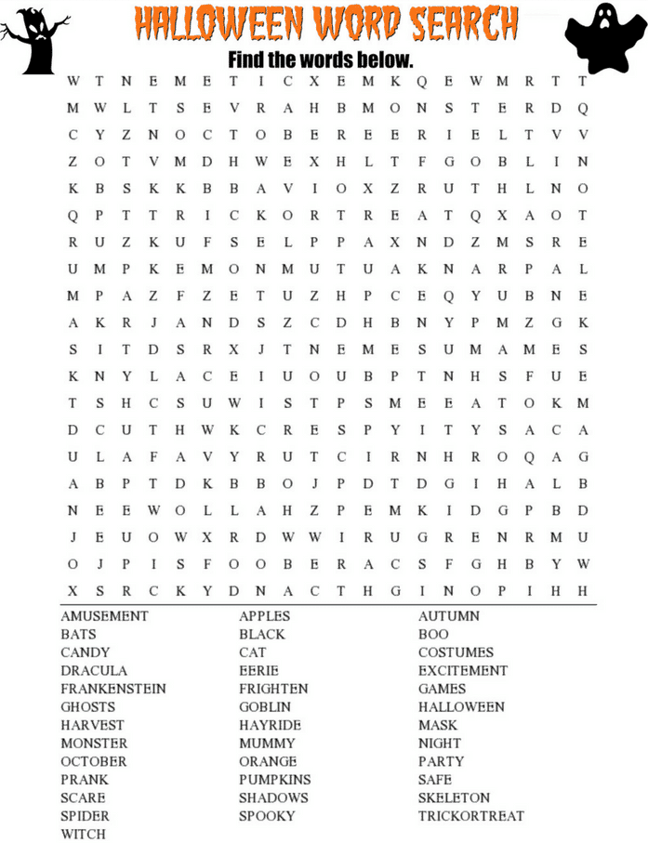

Get a Night Out at the Movies for 2 with my

**Referral Rewards Program**

As you probably know, advertising is very expensive. Instead of paying the newspaper or another place to advertise, we’d rather reward you. So, we’ve assembled the Referral Rewards Program.

Every time you refer someone who becomes a client, we will send you a gift certificate for two passes to the **Movies-8 Cinema.**

And Hey! What’s a movie without popcorn? The gift certificate will also cover a big box of hot, buttered popcorn and sodas!

**Welcome to our new and returning clients!**

Click on the text box and Insert names

**A gigantic THANK YOU to all who referred us last month…**

Insert names