

Reliable news for healthy living, saving money, and having fun!



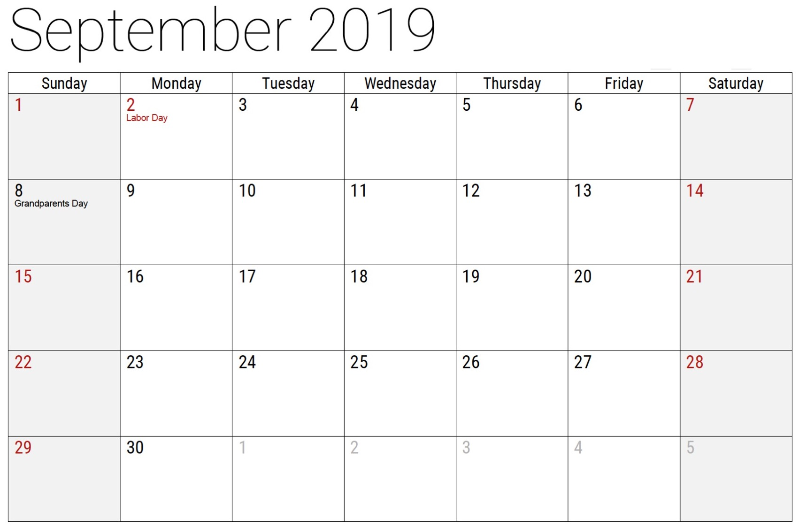

**September 2**

Labor Day

**September 8**

Grandparent’s Day

**September 23**

Fall Equinox

(Fall Begins)

September 2019

**Jimbo’s Floors**

Suzie Smith!

You are this month’s   
Mystery Winner!

We have a   
**$10.00 Starbucks   
gift card**   
reserved just for you!

Come by our store to   
claim your prize!

Inside This Issue…

* Are you this month’s Mystery Winner?
* Month at a Glance
* Grandparent’s Day
* Mega Trivia Contest
* Did you Know
* Ungluing Those Fixed Expenses
* Thank you for the Kind Words
* Client of the Month
* Our Solar System

Dear Friends,

Your personal message goes here.

The personal message is important because it allows you to connect in a very personal way with your clients. This personal connection is sorely lacking in most businesses. Topic ideas:

Your hobbies

Something interesting happening this month. Wish them “Merry Christmas” or “Happy Thanksgiving.”

A thought from your heart

Appreciation for your clients and their referrals. Remind them that you will bend over backwards to provide their referrals with World Class Service.

Mention that month’s “special offer” insert

Your Friend,

Your Signature

Your Name

Month at a Glance!

Scan to see our website

*“You’ll love your new floors, or I’ll replace them free!”*

~Jim Armstrong & Mick  
[www.JimbosFloors.com](http://www.JimbosFloors.com)

**HOLIDAY SCHEDULE WARNING:**

Jimbo’s Floors is in very high demand, and we are booked out for several weeks. If you are even thinking of having new flooring installed for Thanksgiving and Christmas, I implore you to run (don’t walk) to our showroom and book your installation now, even if you don’t need it for a month or two.

If you come in at the last minute we’ll do our best to fit you in, but it’s very likely you’ll have to wait for several weeks. Don’t take that chance!

*CALL OR VISIT US NOW!!*

-Jim A.

Who is the only Disney villain to never actually appear onscreen in their prospective Disney film?

A) Scar B) Ursula

C) Jafar D) “Man” from Bambi

To enter, email [Jimbo@JimbosFloors.com](mailto:Jimbo@JimbosFloors.com) with the subject line: “Mega Trivia Contest.” Take your best guess…your chances of winning are better than you think!

Falling on the first Sunday after Labor Day each year, Grandparents’ Day is a special family day designed to bring attention to the strength, guidance and knowledge held by older members of our society.

Deliberately chosen to take place in September, as autumn begins, Grandparents’ Day is to honor the vital role individuals in the autumn years of their life have in families and our history, and their impact, forethought, and importance on future generations.

Compared to Mother’s and Father’s Day, Grandparents’ Day is more recent in North America. Its history started in the United States in 1970. Marian McQuade, from West Virginia, a mother of 15 who considered herself a mere housewife began this special day. Focused on educating, it was her goal that young people understand the significant contributions seniors have made throughout history.

Though McQuade’s campaign for Grandparents’ Day began in 1970, after working vigilantly with leaders in the community, business, politics, and the church, it wasn’t until 1973 when Virginia had its first Grandparents’ Day. She persistently continued toward the goal of national recognition and, in 1979, President Jimmy Carter proclaimed that the first Sunday after Labor Day would be National Grandparents’ Day.

In Canada, Grandparents’ Day began in 1995 on the second Sunday in September to honor the role of nurturing, upbringing, and educating children that grandparents have in strengthening families.





### Who Else Wants to Win

### Dinner for Two

### at the City Café!

### Take our Trivia Challenge and *you could win too!*

This month’s Mega Trivia question:

**Answer to last month’s question: D) Vietnam and Brazil**

Congratulations to last month’s winner: **Client Name**

Grandparent’s Day



In any household budget there are two main sections: fixed expenses and variable expenses. Variable (discretionary) expenses differ from one month to the next, including such items as Food, Clothing and Entertainment.

Fixed expenses recur at the same time every month, and are usually the same amount each time, barring a major change like a new home or vehicle. The sums usually come out of your account automatically. Here are some examples:

1. Mortgage or Rent/Home Insurance/Taxes

2. Loan Repayment

3. Vehicle Payment/ Insurance/Plates

4. Cable/Phone/Internet

5. Utilities: vary with time of year

6. Membership Fees

But for many of us the end of the money arrives before the end of the month. Is there anything we can do about ungluing these fixed expenses?



Let’s take them one by one:

1. Mortgage payments made bi-weekly or weekly get you debt-free faster. If you think your income is about to take a hit, consider downsizing, whether you own or rent.

2. Make the payments you must make, but choose your highest interest loan and make higher payments on it – stop using it too. Once that loan is gone, choose the next highest rate – rinse and repeat.

3. Once a new car is driven off the lot, value drops like a stone. Consider an older vehicle, which lowers your payment and insurance, but make sure you budget some extra funds for maintenance.

4. Bundle, combine, downsize, drop.

5. Turn thermostats down in the winter, up in the summer. Choose energy efficient appliances, don’t leave equipment on unnecessarily.

6. If you don’t go/participate regularly, you likely don’t need it. Lift weights at home, do sit-ups or go for a jog.

Next month: variable expenses

Thank You for the Kind Words!

“My new laminate floors in my kitchen and dining room are beautiful. I was treated with respect and courtesy as a single woman raising a daughter. I genuinely felt that Jim Armstrong and his staff display concern for my flooring needs and were a guiding light for me. I recommend his service to anyone looking for a supportive, positive experience.”

~Marsha Avalos, School Teacher, Yuba City

“We Recently went to Jimbo’s Floors for new tile for our bathroom, and we’re thrilled with the results! This is our third time using Jimbo’s. Jim will never make you feel uncomfortable for asking questions and he’ll do anything in his power to accommodate your needs. When you do business with Jim and the staff at Jimbo’s Floors, you will be treated like royalty. Our experience was painless and very professional. Jim is not only our flooring expert, he’s a friend. That’s how he makes you feel.”

~Marvin and Sandy Moeller, owners of Sierra Landscaping, Yuba City

Congratulations to our client of the month,

**Susan Johnson!**

Susan is a 3rd time returning client, and she recently purchased new laminate for her kitchen and dining room. She always has a big smile on her face and is a lot of fun to work with. *Thanks, Susan!*

As always, our clients of the month receive **2 movie passes for Movies-8!**

*Watch for your name here in a coming month!*

UNGLUING THOSE FIXED EXPENSES



Asteroid

Ceres

Comet

Dwarf

Earth

Enceladus

Europa

Jupiter

Mars

Mercury

Meteor

Moon

Neptune

Planet X

Pluto

Saturn

Sun

Titan

Uranus

Venus

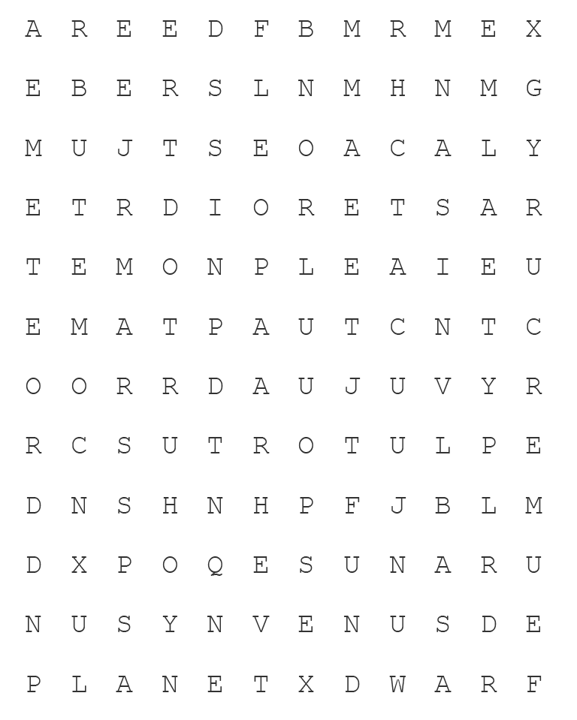

Get a Night Out at the Movies for 2 with my

**Referral Rewards Program**

As you probably know, advertising is very expensive. Instead of paying the newspaper or another place to advertise, we’d rather reward you. So, we’ve assembled the Referral Rewards Program.

Every time you refer someone who becomes a client, we will send you a gift certificate for two passes to the **Movies-8 Cinema.**

And Hey! What’s a movie without popcorn? The gift certificate will also cover a big box of hot, buttered popcorn and sodas!

**Welcome to our new and returning clients!**

Click on the text box and Insert names

**A gigantic THANK YOU to all who referred us last month…**

Insert names

OUR SOLAR SYSTEM

**Be sure to stop by to pick out and schedule   
your new floor installation, and   
from our families to yours have a great month!**

**Your Company Name**

123 Address, Someplace, ZZ 555555

555.555.5555 Phone ⚫ 555.555.5555 Fax

email@yourcompanyname.com

**YourCompanyWebsite.com**