

Reliable news for healthy living, saving money, and having fun!

********

**August 5th**

Civic/Provincial Day (Regions of Canada)

**August 7**

Purple Heart Day

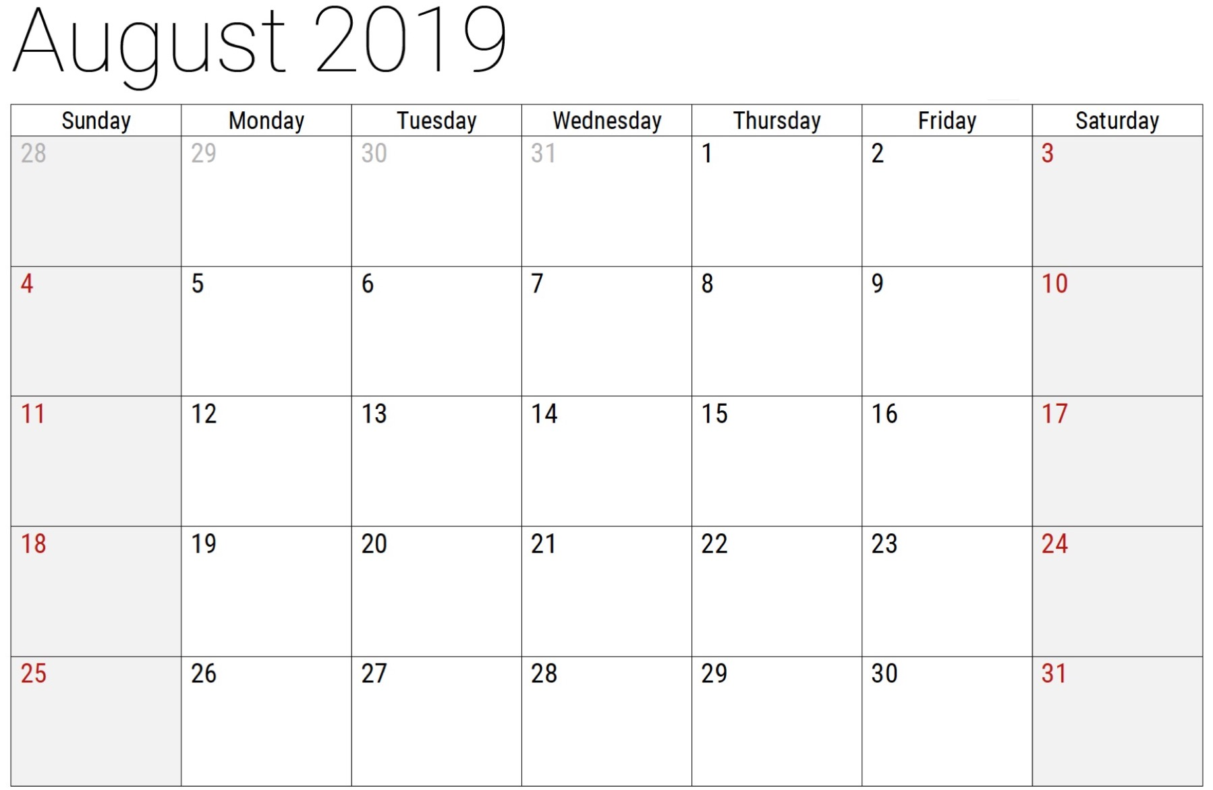

Inside This Issue…

* Are you this month’s Mystery Winner?
* Month at a Glance
* Tips to Avoid a Fire
* Mega Trivia Contest
* Did you Know
* Before you hire a plumber
* Thank you for the Kind Words
* Client of the Month
* August Rush is Right
* Thank you to our clients

Suzie Smith!

You are this month’s   
Mystery Winner!

We have a   
**$10.00 Starbucks   
gift card**   
reserved just for you!

Come by our store to   
claim your prize!

Scan to see our website

Dear Friends,

Your personal message goes here.

The personal message is important because it allows you to connect in a very personal way with your clients. This personal connection is sorely lacking in most businesses. Topic ideas:

Your hobbies

Something interesting happening this month. Wish them “Merry Christmas” or “Happy Thanksgiving.”

A thought from your heart

Appreciation for your clients and their referrals. Remind them that you will bend over backwards to provide their referrals with World Class Service.

Mention that month’s “special offer” insert

Your Friend,

Your Signature

Your Name

*“You’ll love your new floors or I’ll replace them free!”*

~Jim Armstrong & Mick  
[www.JimbosFloors.com](http://www.JimbosFloors.com)

**Jimbo’s Floors**

August 2019

Month at a Glance!

**We’d be happy to**

**send you our electronic newsletter!**

The same combination of useful tips and offbeat stories you read here, but with these differences:

The e-Neighborhood Advisor will arrive in your email account once you give us permission

We send it once a week

The e-Neighborhood Advisor does not have the same content as the print Neighborhood Advisor – you’ll read all new stories, from helpful advice to items that give you a smile

Simply let us know which email account you’d like us to use for the e-Neighborhood Advisor.



**Tips to Avoid a Fire**

The concern of all homeowners is how to protect our property and keep everyone safe, and that begins with each of us being educated and prepared.

There are definite ways to prevent accidental house fires. Consider these common causes of house fires and how you can prevent them.

**Keep an eye on the flame**

There is beauty and tranquility to candles, but approximately four percent of residential fires are the result of lit candles. If you enjoy candles, keep them in sturdy holders out of reach of children and pets; keep the flame away from anything that could catch fire; and extinguish the flame before leaving the room.

**Stay in the kitchen**

A top cause of fires in the kitchen is becoming distracted or leaving what’s cooking unattended. It takes seconds for an overheated pan or grease spatters to cause a fire, or leaving combustibles too near the heat, like oven mitts, dish towels, and other flammable items. When the heat is on in the kitchen, stay until the cooking gets done.

**Clean the grill**

Home barbecues are another source of home fires either from a buildup of grease and food particles or being used too close to the house. Be sure to keep the barbecue away from the house, deck rails, tablecloths, trees, and branches. Regularly clean removable parts inside and out with warm soapy water. Also, put soapy water in a spray bottle, then spray connection points to check for gas leaks. A leak will bubble when the gas is on.

**Get the lint out**

Thousands of fires each year start with the clothes dryer due to lint and other debris clogging the dryer vent. The first signs that this buildup is happening is clothes aren’t drying thoroughly and drying time is taking longer or clothes seem unusually hot after the drying cycle. With the reduction of air flow, the dryer is unable to exhaust heat and moisture correctly. That means the dryer works harder and more intense heat builds up. This could lead to a dryer vent fire. It's recommended that you get dryer vent cleaning done annually.

Which two countries produce the most coffee?

A) Columbia and Brazil; B) Indonesia and Peru

C) Costa Rica and Kenya; D) Vietnam and Brazil

To enter, email [Jimbo@JimbosFloors.com](mailto:Jimbo@JimbosFloors.com) with the subject line: “Mega Trivia Contest.” Take your best guess…your chances of winning are better than you think!

### Who Else Wants to Win

### Dinner for Two

### at the City Café!

### Take our Trivia Challenge and *you could win too!*

This month’s Mega Trivia question:

**Answer to last month’s quiz: C) 195**

Congratulations to last month’s winner:  **Client Name**

Congratulations to our client of the month,

**Susan Johnson!**

Susan is a 3rd time returning client, and she recently purchased new laminate for her kitchen and dining room. She always has a big smile on her face and is a lot of fun to work with. *Thanks, Susan!*

As always, our clients of the month receive **2 movie passes for Movies-8!**

*Watch for your name here in a coming month!*

“My new laminate floors in my kitchen and dining room are beautiful. I was treated with respect and courtesy as a single woman raising a daughter. I genuinely felt that Jim Armstrong and his staff display concern for my flooring needs and were a guiding light for me. I recommend his service to anyone looking for a supportive, positive experience.”

~Marsha Avalos, School Teacher, Yuba City

“We Recently went to Jimbo’s Floors for new tile for our bathroom, and we’re thrilled with the results! This is our third time using Jimbo’s. Jim will never make you feel uncomfortable for asking questions and he’ll do anything in his power to accommodate your needs. When you do business with Jim and the staff at Jimbo’s Floors, you will be treated like royalty. Our experience was painless and very professional. Jim is not only our flooring expert, he’s a friend. That’s how he makes you feel.”

~Marvin and Sandy Moeller, owners of Sierra Landscaping, Yuba City

Thank You for the Kind Words!

It's no secret how vital plumbing is to our home and how chaotic things can get when it goes awry.

A broken sink, toilet, leaking pipe, or dripping tap can quickly test the limits of your sanity. Not only do these increase your water usage and expense, it means you need to find a good plumber without killing your budget.

The best price is not always the best choice. For efficiency and to ensure the repair gets fixed right the first time, you’ll need to ask questions before hiring the plumber to do the job.

Is the person and business licensed?

When the person is appropriately licensed it means he/she meets regulated requirements and adheres to industry standards and guidelines. When a person is unlicensed, you could become vulnerable to greater loss from poor workmanship. It is also worth checking what professional registrations the business maintains.

Is the person experienced?

The appropriate licenses and registrations alone do not make a plumber great. Find out how long the business has been in operation and the level of the plumber's experience. Experienced professionals focus on providing you with a high-quality experience and workmanship.

Are they insured?

Without appropriate insurance, the onus is on you to pay for any damages if a worker suffers injuries due to an accident while working in your home.

What are the warranty terms?

You want a contractor who will guarantee their work. If there is hesitation or reluctance to warranty the job, then it could mean trouble.

There are other considerations before hiring the right expert for the job. When you are looking for plumbers, compare prices and ask for references. Be sure to contact the references too. Google and Facebook are great resources for previous client feedback and reviews.

Of course, these tips are useful when considering any contractor to work on your home.

Before You Hire a Plumber



**Answers:**



**Be sure to stop by to pick out and schedule   
your new floor installation, and   
from our families to yours have a great month!**

**August Rush is right!**

If you’re looking for a good movie to watch this month, consider the 2007 film August Rush.

The main character, an orphan named Evan, spoke this quote that you will discover by rearranging the letters in each column in the correct boxes above.



**Your Company Name**

123 Address, Someplace, ZZ 555555

555.555.5555 Phone ⚫ 555.555.5555 Fax

email@yourcompanyname.com

**YourCompanyWebsite.com**

**Welcome to our new and returning clients!**

Click on the text box and Insert names

**A gigantic THANK YOU to all who referred us last month…**

Insert names

Get a Night Out at the Movies for 2 with my

**Referral Rewards Program**

As you probably know, advertising is very expensive. Instead of paying the newspaper or another place to advertise, we’d rather reward you. So we’ve assembled the Referral Rewards Program.

Every time you refer someone who becomes a client, we will send you a gift certificate for two passes to the **Movies-8 Cinema.**

And Hey! What’s a movie without popcorn? The gift certificate will also cover a big box of hot, buttered popcorn and sodas!