

Reliable news for healthy living, saving money, and having fun!

********

**June 14**

Flag Day (US)

**June 16**

Father's Day

**June 19**

Juneteenth (US)

**June 21**

June Solstice

**June 21:**

National Aboriginal Day (Canada)

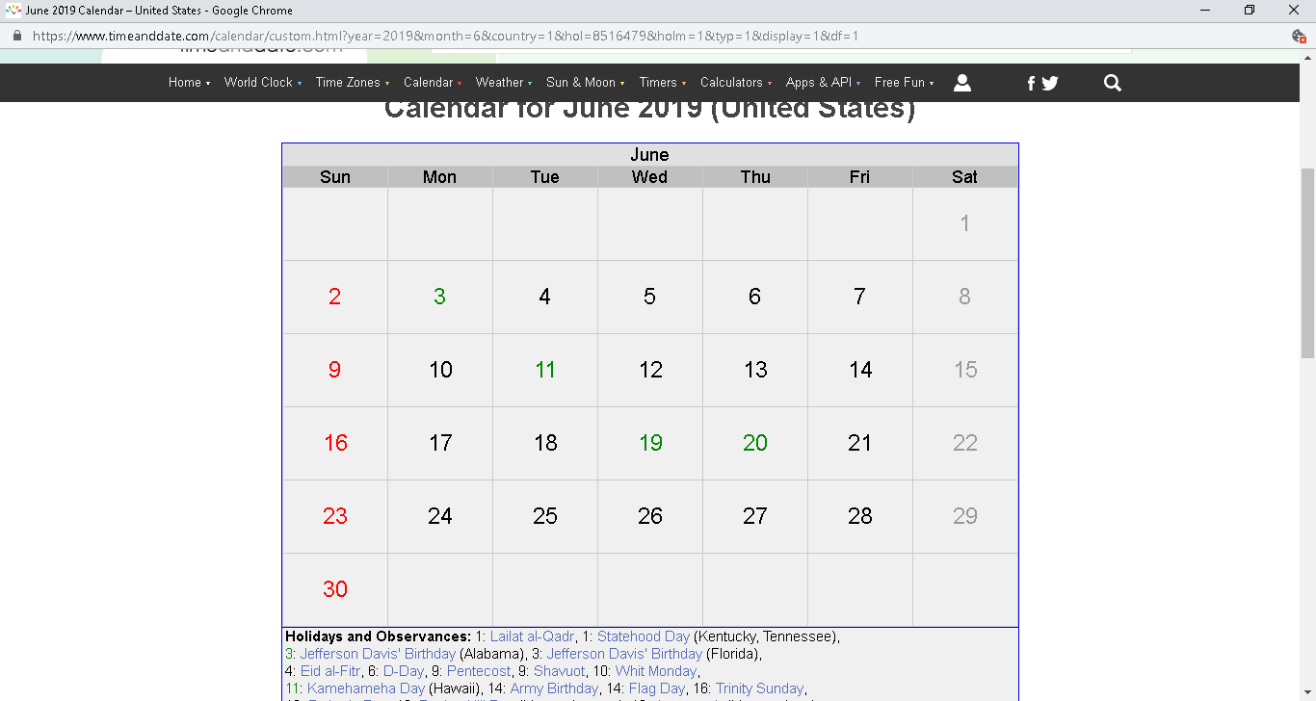

Inside This Issue…

* Are you this month’s Mystery Winner?
* Month at a Glance
* Power Smile!
* Mega Trivia Contest
* Did you Know
* Attack Carpet Spots
* Thank you for the Kind Words
* Client of the Month
* Dad’s Advice Brain Teaser

Suzie Smith!

You are this month’s   
Mystery Winner!

We have a   
**$10.00 Starbucks   
gift card**   
reserved just for you!

Come by our store to   
claim your prize!

Scan to see our website

Dear Friends,

Your personal message goes here.

The personal message is important because it allows you to connect in a very personal way with your clients. This personal connection is sorely lacking in most businesses. Topic ideas:

Your hobbies

Something interesting happening this month. Wish them “Merry Christmas” or “Happy Thanksgiving.”

A thought from your heart

Appreciation for your clients and their referrals. Remind them that you will bend over backwards to provide their referrals with World Class Service.

Mention that month’s “special offer” insert

Your Friend,

Your Signature

Your Name

*“You’ll love your new floors or I’ll replace them free!”*

~Jim Armstrong & Mick  
[www.JimbosFloors.com](http://www.JimbosFloors.com)

**Jimbo’s Floors**

June 2019

Month at a Glance!



**Today, give a stranger**

**one of your smiles.**

**It might be the only sunshine he sees all day.**

~ H. Jackson Brown Jr

in P.S. I Love You



**We’d be happy to send you our electronic newsletter!**

The same combination of useful tips and offbeat stories you read here, but with these differences:

* The e-Advisor will arrive in your email account once you give us permission
* We send it once a week
* The e-Advisor does not have the same content as the print Home Advisor – you’ll read all new stories, from helpful advice to items that give you a smile

Simply let us know which email account you’d like us to use for the e-Advisor.

### Who Else Wants to Win

### Dinner for Two

### at the City Café!

### Take our Trivia Challenge and *you could win too!*

This month’s Mega Trivia question:

**Answer to last month’s quiz: C) December**

Congratulations to last month’s winner:  **Client Name**

**A group of crows is known as a:**

A) crowd B) flock

C) murder D) swarm

To enter, email [Jimbo@Jimbosfloors.com](mailto:Jimbo@Jimbosfloors.com) with the subject line: “Mega Trivia Contest.” Take your best guess…your chances of winning are better than you think!

Go for a power smile! The simple act of smiling, forced or not, is one action that powerfully affects you and those around you.

The best time to smile is when you feel down or simply don't feel like you have anything to smile about. Here's why:

**It lowers stress and anxiety**

The simple act of smiling lowers heart rate better than plain and frowning facial expressions. Plus, smiling releases a chemical called endorphins, which makes us happy.

**It's a free facelift**

Smiles soften harsh lines created by worry and frowns. In fact, one study found that smiling people are considered more attractive, trustworthy, and approachable.

**It's Contagious**

We all want to have a positive impact on around us. Often the mere sight of someone smiling engages an automatic response to grin.

Like a power walk, power smile and pass it on! Whether it is on *Smile Power Day* (June 15th) or every day, choose to smile, especially when you don’t feel like it and share that smile with the world. Get everyone's happy endorphins moving!

Power Smile!

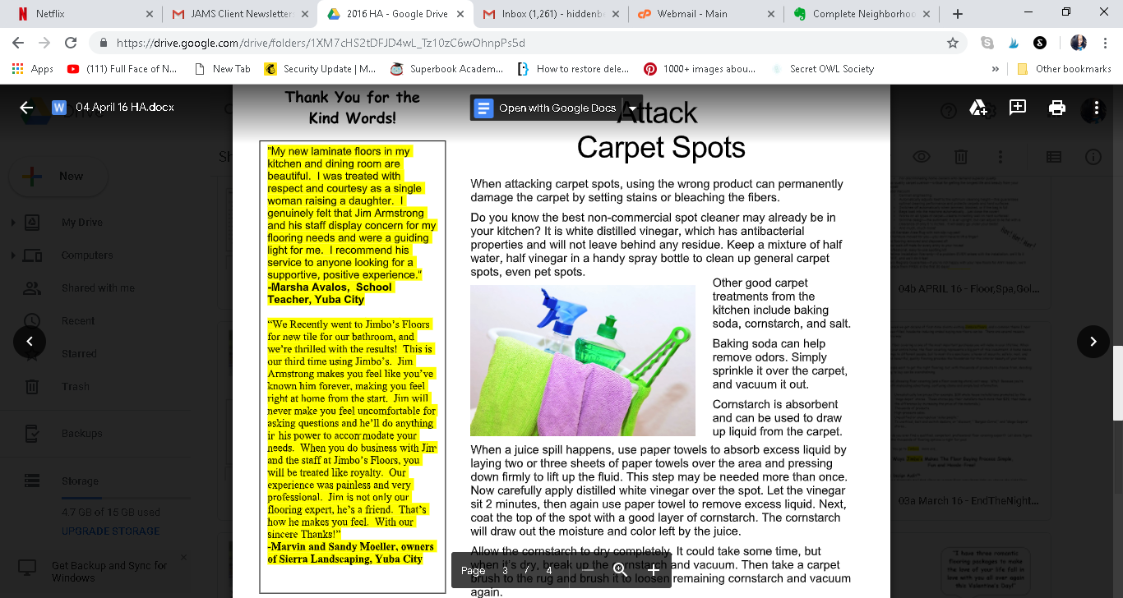

Attack Carpet Spots

When attacking carpet spots, using the wrong product can permanently damage the carpet by setting stains or bleaching the fibers.

Do you know the best non-commercial spot cleaner may already be in your kitchen? It is white distilled vinegar, which has antibacterial properties and will not leave behind any residue. Keep a mixture of half water, half vinegar in a handy spray bottle to clean up general carpet spots, even pet spots.

Other good carpet treatments from the kitchen include baking soda, cornstarch, and salt.

Baking soda can help remove odors. Simply sprinkle it over the carpet, and vacuum it out. Cornstarch is absorbent and can be used to draw up liquid from the carpet.

When a juice spill happens, use paper towels to absorb excess liquid by laying two or three sheets of paper towels over the area and pressing down firmly to lift up the fluid.

This step may be needed more than once. Now carefully apply distilled white vinegar over the spot. Let the vinegar sit 2 minutes, then again use paper towel to remove excess liquid. Next, coat the top of the spot with a good layer of cornstarch.

The cornstarch will draw out the moisture and color left by the juice.

Allow the cornstarch to dry completely. It could take some time, but when it’s dry, break up the cornstarch and vacuum. Then take a carpet brush to the rug and brush it to loosen remaining cornstarch and vacuum again.

Salt combined with warm water can be used to remove blood from the carpet. Make sure the salt is dissolved completely before working it into the spot.



Congratulations to our client of the month,

**Susan Johnson!**

Susan is a 3rd time returning client, and she recently purchased new laminate for her kitchen and dining room. She always has a big smile on her face and is a lot of fun to work with. *Thanks, Susan!*

As always, our clients of the month receive **2 movie passes for Movies-8!**

*Watch for your name here in a coming month!*

“My new laminate floors in my kitchen and dining room are beautiful. I was treated with respect and courtesy as a single woman raising a daughter. I genuinely felt that Jim Armstrong and his staff display concern for my flooring needs and were a guiding light for me. I recommend his service to anyone looking for a supportive, positive experience.”

~Marsha Avalos, School Teacher, Yuba City

“We Recently went to Jimbo’s Floors for new tile for our bathroom, and we’re thrilled with the results! This is our third time using Jimbo’s. Jim will never make you feel uncomfortable for asking questions and he’ll do anything in his power to accommodate your needs. When you do business with Jim and the staff at Jimbo’s Floors, you will be treated like royalty. Our experience was painless and very professional. Jim is not only our flooring expert, he’s a friend. That’s how he makes you feel.”

~Marvin and Sandy Moeller, owners of Sierra Landscaping, Yuba City

Thank You for the Kind Words!



*My father taught me that the only way you can make good at anything is to practice and then practice some more.*

Answers:

Brain teasers are those thought inducing puzzles that often require unconventional and out-of-the-box thinking to solve. They are a source of fun, learning and help keep our brains actively on the right path.

This is a Letter Tile puzzle. Place the tiles in the right order to discover the Pete Rose quote hidden within this jumbled mess.

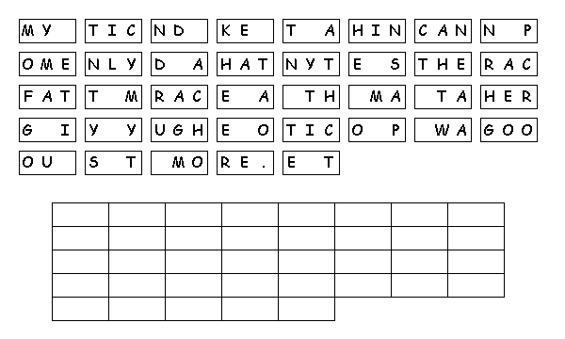

**Dad’s Advice Brain Teaser**

**Be sure to stop by to pick out and schedule   
your new floor installation, and   
from our families to yours have a great month!**

**Your Company Name**

123 Address, Someplace, ZZ 555555

555.555.5555 Phone ⚫ 555.555.5555 Fax

email@yourcompanyname.com

**YourCompanyWebsite.com**

**Welcome to our new and returning clients!**

Click on the text box and Insert names

**A gigantic THANK YOU to all who referred us last month…**

Insert names

Get a Night Out at the Movies for 2 with my

**Referral Rewards Program**

As you probably know, advertising is very expensive. Instead of paying the newspaper or another place to advertise, we’d rather reward you. So we’ve assembled the Referral Rewards Program.

Every time you refer someone who becomes a client, we will send you a gift certificate for two passes to the **Movies-8 Cinema.**

And Hey! What’s a movie without popcorn? The gift certificate will also cover a big box of hot, buttered popcorn and sodas!