

Reliable news for healthy living, saving money, and having fun!

****

**May 5:**

Cinco de Mayo (US)

**May 12:**

Mother's Day

**May 20:**

Victoria Day (Canada)

**May 27:**

Memorial Day (US)

May 2019

**Jimbo’s Floors**

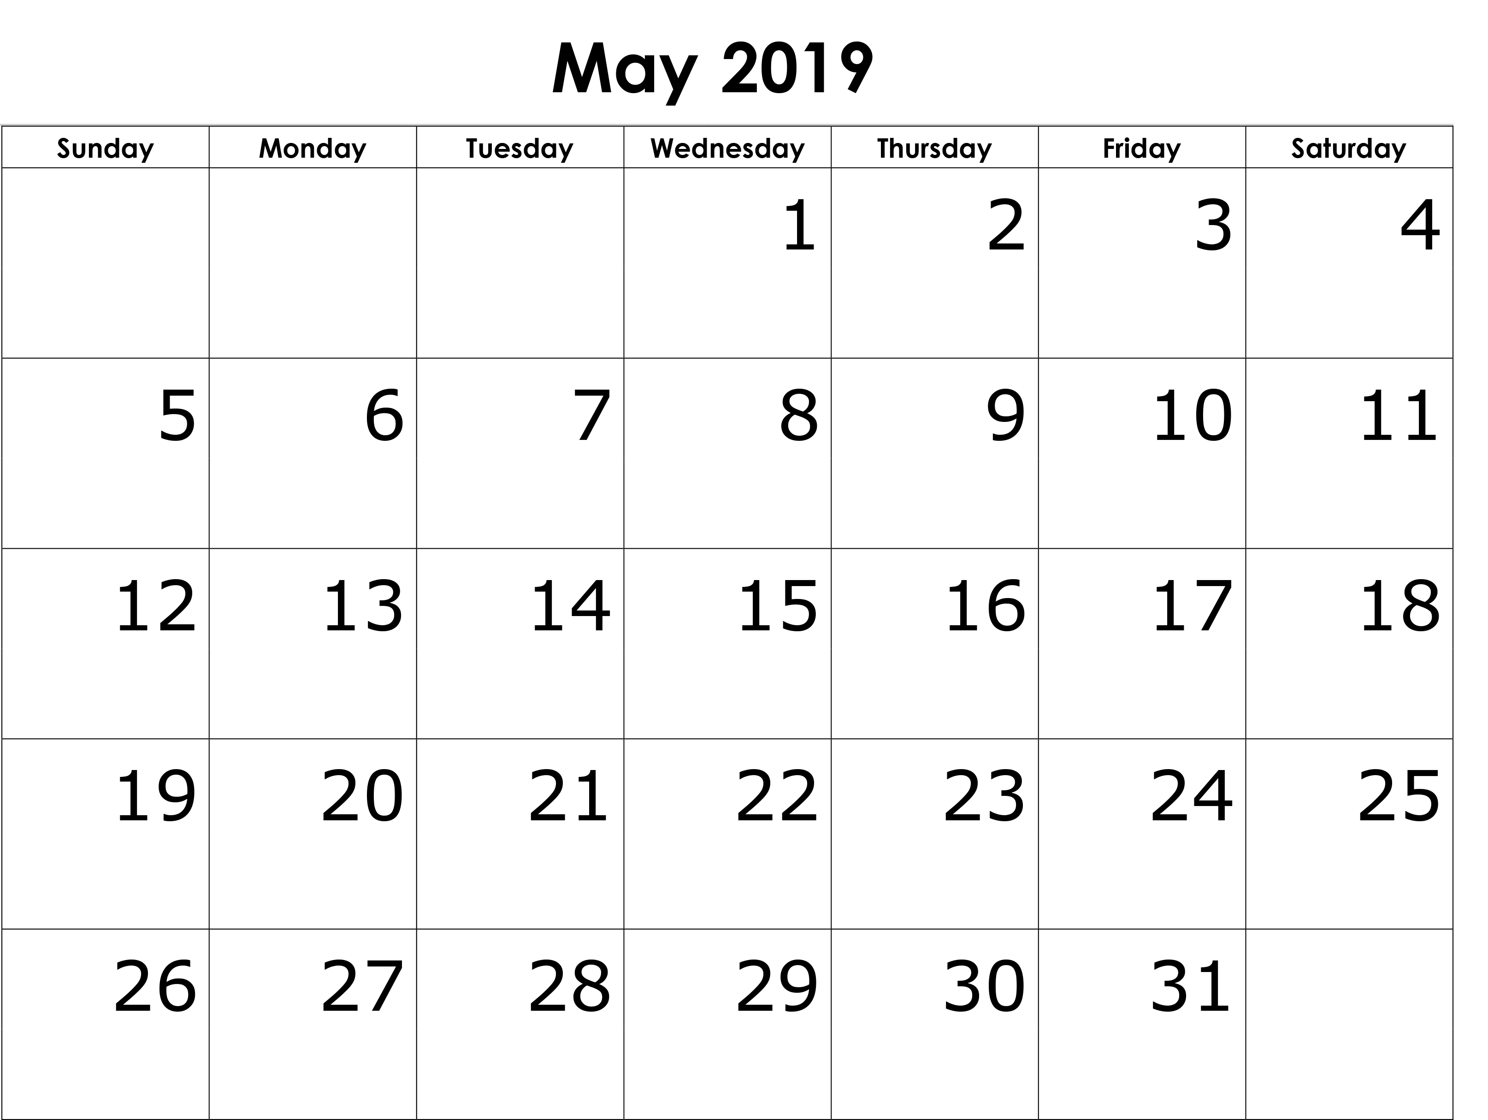

Suzie Smith!

You are this month’s   
Mystery Winner!

We have a   
**$10.00 Starbucks   
gift card**   
reserved just for you!

Come by our store to   
claim your prize!

Inside This Issue…

* Are you this month’s Mystery Winner?
* Month at a Glance
* April Showers Bring May Flowers
* Mega Trivia Contest
* Did you Know
* Four Ways to Spend Less
* Thank you for the Kind Words
* Client of the Month
* Gifts and Places of May
* New and Returning Clients
* Get a Night Out @ The Movies

Dear Friends,

Your personal message goes here.

The personal message is important because it allows you to connect in a very personal way with your clients. This personal connection is sorely lacking in most businesses. Topic ideas:

Your hobbies

Something interesting happening this month. Wish them “Merry Christmas” or “Happy Thanksgiving.”

A thought from your heart

Appreciation for your clients and their referrals. Remind them that you will bend over backwards to provide their referrals with World Class Service.

Mention that month’s “special offer” insert

Your Friend,

Your Signature

Your Name

Month at a Glance!

Scan to see our website

*“You’ll love your new floors, or I’ll replace them free!”*

~Jim Armstrong & Mick  
[www.JimbosFloors.com](http://www.JimbosFloors.com)



May flowers are blooming, and the weather is getting warmer! It’s the time of year when we emerge more frequently from our homes to bask in the sunshine and fill our lungs with fresh springtime air.

Whether it’s looking forward to enjoying nature’s palette of natural colors or to enrich a manicured landscape surrounding the home, many are also thinking about their gardens.

Gardens can be a great source of inspiration for people in a variety of ways – like getting creative juices flowing in art, music, writing, even cooking! Plus, some flowers are edible like varieties of Borage, Calendula, Hibiscus, Lavender, Sage, Pansies, Roses, Nasturtiums, and more!

There are popular garden flowers like tulips, roses, and hearty little bushes that can survive in cold and dry climates.

Prevalent in dry climates are Carissa shrubs or small trees, Hibiscus and Lantana plants, which are all native to warm, tropical or subtropical climates. Plus, they come in a rainbow of brilliant colors.

Cold climate flowers include Blue star, which looks as the name suggests. There is Hollyhock, hearty and durable red flowers; purple Windflowers, along with red and orange Yarrow.

If you like shrubs in the garden, then consider Barberry, Azalea bushes, Oleander, or Honeysuckle in warm climates, and look for Bugleweed, Dawn Viburnum, Daphne, or Artemisia in cold climates.

Gardens aside, let’s all get outside and soak up vitamin D from the sunshine and breath in a whole lot of that fresh air!



**You are protected by**

**Jimbo’s 100% Iron-Clad**

**Triple Guarantee!**

**#1 “Zero Regrets Guarantee!”**

**You’ll love your new floors, or I’ll replace them FREE!** If at any time during the first 30 days after installation you decide you don’t like your new flooring for whatever reason, just let me know. I’ll replace the materials free of charge.

**#2 Lifetime Installation Warranty**

I offer a lifetime installation warranty at Jimbo’s Floors. You NEVER have to worry about something going wrong with the installation. If it does, I’ll fix it FREE! And I’ll do it quickly.

**#3 Installer Professionalism Guarantee**

Jimbo’s Floorsinstallers are neat, clean, well-groomed, well-spoken and professional. You’ll receive the highest-quality installation in the business. And after they’re finished, they will leave your home as neat and clean as when they arrived!

What is the last word of this line - *'It's a long, long, time from May to ______*” - in a Frank Sinatra song?

A) September B) January

C) December D) November

To enter, email [Jimbo@Jimbosfloors.com](mailto:Jimbo@Jimbosfloors.com) with the subject: “Mega Trivia Contest.” Take your best guess…your chances of winning are better than you think!

(NOTE: see the NA instructions for this month if you don’t have the Jim Armstrong Marketing Website to direct them to.)

### Who Else Wants to Win

### Dinner for Two

### at the City Café!

### Take our Trivia Challenge and *you could win too!*

This month’s Mega Trivia question:

**Answer to last month’s question: B) Wallpaper**

Congratulations to last month’s winner: **Client Name**

April Showers Bring May Flowers



Four Ways to Spend Less



Whether saving for a vacation, a renovation or a big-ticket item, looking for small ways to save money reduces the stress when it’s time to pay. Little bits of savings amount to a lot over time! Here are a few ways to save for future wants and needs.

Books and Magazines

Before buying books and magazines, borrow from the local library. There are also excellent resources for hobbies and research, and some are available online.

TV and Movies

Many television programs and movies are available on Internet streaming apps. Movies can be available within a few months and TV series within a season or two from when they are initially released. These apps can be less costly than satellite and cable services.

Meal Planning

Save a lot by watching the sales, planning out weekly meals and cooking at home. Some people do once-a-week cooking and meal prep. This saves time and money, particularly when you have your homemade meals ready in the fridge and freezer. That helps avoid a drive-thru and junk food because you’re strapped for time.

“Shop” at Home

Sometimes we forget what we already have and buy duplicates. Or we wear a select number of items from the closet, which leaves a plethora of good clothes to choose from for a 'new' outfit. Rather than spend money on something new, shop in drawers, closets and stashed stuff that you already have at home.

“My new laminate floors in my kitchen and dining room are beautiful. I was treated with respect and courtesy as a single woman raising a daughter. I genuinely felt that Jim Armstrong and his staff display concern for my flooring needs and were a guiding light for me. I recommend his service to anyone looking for a supportive, positive experience.”

~Marsha Avalos, School Teacher, Yuba City

“We Recently went to Jimbo’s Floors for new tile for our bathroom, and we’re thrilled with the results! This is our third time using Jimbo’s. Jim will never make you feel uncomfortable for asking questions and he’ll do anything in his power to accommodate your needs. When you do business with Jim and the staff at Jimbo’s Floors, you will be treated like royalty. Our experience was painless and very professional. Jim is not only our flooring expert, he’s a friend. That’s how he makes you feel.”

~Marvin and Sandy Moeller, owners of Sierra Landscaping, Yuba City

Congratulations to our client of the month,

**Susan Johnson!**

Susan is a 3rd time returning client, and she recently purchased new laminate for her kitchen and dining room. She always has a big smile on her face and is a lot of fun to work with. *Thanks, Susan!*

As always, our clients of the month receive **2 movie passes for Movies-8!**

*Watch for your name here in a coming month!*

Thank You for the Kind Words!

**Words:**

BRUNCH CAMPING CLOTHES COTTAGE

DAUGHTER DINNER FLOWERS GIFTS

JEWELRY MEMORIES MOM PICTURES

SISTER STEPMOM TRAVEL

Get a Night Out at the Movies for 2 with my

**Referral Rewards Program**

As you probably know, advertising is very expensive. Instead of paying the newspaper or another place to advertise, we’d rather reward you. So, we’ve assembled the Referral Rewards Program.

Every time you refer someone who becomes a client, we will send you a gift certificate for two passes to the **Movies-8 Cinema.**

And Hey! What’s a movie without popcorn? The gift certificate will also cover a big box of hot, buttered popcorn and sodas!

**Welcome to our new and returning clients!**

Click on the text box and Insert names

**A gigantic THANK YOU to all who referred us last month…**

Insert names

Gifts and Places of May

**Be sure to stop by to pick out and schedule   
your new floor installation, and   
from our families to yours have a great month!**

**Your Company Name**

123 Address, Someplace, ZZ 555555

555.555.5555 Phone ⚫ 555.555.5555 Fax

email@yourcompanyname.com

**YourCompanyWebsite.com**