

Reliable news for healthy living, saving money, and having fun!

April 1:

**April Fools Day**

April 9:

**Vimy Ridge Day (Canada)**

April 15:

**Tax Day (USA)**

April 19:

**Good Friday**

April 21:

**Easter Sunday**

April 30:

**Income Tax Day (Canada)**

April 2019

**Jimbo’s Floors**

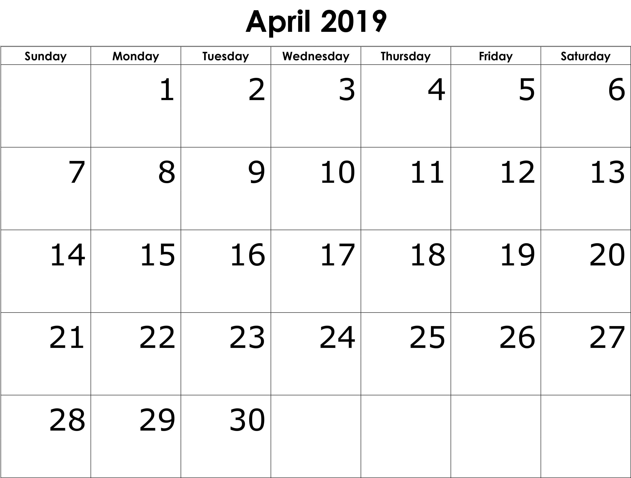

Suzie Smith!

You are this month’s   
Mystery Winner!

We have a   
**$10.00 Starbucks   
gift card**   
reserved just for you!

Come by our store to   
claim your prize!

Inside This Issue…

* Are you this month’s Mystery Winner?
* Month at a Glance
* Spring Clean the Car
* Mega Trivia Contest
* Did you Know
* Easter Dates and Bunnies
* Thank you for the Kind Words
* Client of the Month
* About April, William Shakespeare said…

Dear Friends,

Your personal message goes here.

The personal message is important because it allows you to connect in a very personal way with your clients. This personal connection is sorely lacking in most businesses. Topic ideas:

Your hobbies

Something interesting happening this month. Wish them “Merry Christmas” or “Happy Thanksgiving.”

A thought from your heart

Appreciation for your clients and their referrals. Remind them that you will bend over backwards to provide their referrals with World Class Service.

Mention that month’s “special offer” insert

Your Friend,

Your Signature

Your Name

Month at a Glance!

Scan to see our website

*“You’ll love your new floors, or I’ll replace them free!”*

~Jim Armstrong & Mick  
[www.JimbosFloors.com](http://www.JimbosFloors.com)

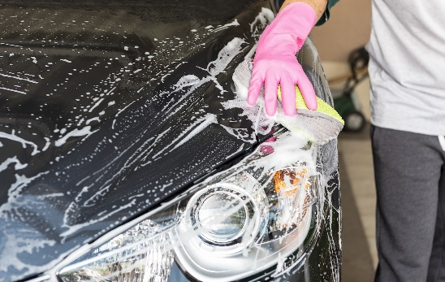

Along with spring cleaning the nooks and crannies in the house, Spring is an excellent time to give the car a little extra TLC!

On the surface, the car may be clean, but there are a lot of tight and hard-to-reach places for dirt.

**Interior**

Take everything out from the interior of the car including floor and trunk mats, cup holders and any other removable part.

Use an air blower to get loose dust and dirt out of vents and away from the console and all tight spaces in the car.

Cotton swabs or gently brushing with a toothbrush will help get dirt and debris out of crevices and other nooks and crannies.

Vacuum the seats, carpets and spaces in between. To reach all the areas under the front seat, adjust them to the fully back position when vacuuming in front of the seat and fully forward when doing behind the seat.

Next, polish all hard surfaces with a microfiber cloth and a cleaning spray that is safe for the car’s interior. For leather, get a leather-safe cleaner and follow the instructions.

**Exterior**

Scrub the tires using a tire-cleaning wash and firm brush.

Pro tip: This is a good time to get the tread checked on summer tires. The minimum tread depth for tires should be no less than 2/32 of an inch.

Be aware that tire performance gets substantially reduced before the tire wears down to that minimum tread depth. You may notice a difference when the tire tread is less than 5/32 of an inch.

This is also a good time to make sure your headlights, tail lights and blinkers are all functioning and that your headlight covers are not scratched or becoming foggy.

Next, hose off the undercarriage of the car to remove any loose dirt and debris, then scrub the body from top to bottom with clean soapy water. Follow the soapy cleanse with a clear water rinse and then dry with a microfiber towel.

After the car is dry, you may choose to wax the body, but be sure to check with the manufacturer for the best option to protect the finish of your car.

________________________________



**Here at Jimbo’s Floors,**

**we use a special diagnostic tool called the Design Audit™.**

Our free Design Audit™ is carefully crafted to take the headache out of shopping for new floors. A simple series of questions allows my expert floor consultants to narrow down the thousands of options to the two or three that exactly match your unique situation.

They’ll provide you with a written, customized “maintenance” plan with their professional recommendations for getting the longest life and beauty out of your floor.

Call or visit us today for your FREE Design Audit!™

Bubble wrap was originally invented to be:

A) Bed liner B) Wallpaper

C) Wrapping paper D) Seat cushion

To enter, go to [www.JimbosFloors.com](http://www.JimbosFloors.com) and click on “Mega Trivia Contest.” Take your best guess…your chances of winning are better than you think!

(NOTE: see the NA instructions for this month if you don’t have the Jim Armstrong Marketing Website to direct them to.)

### Who Else Wants to Win

### Dinner for Two

### at the City Café!

### Take our Trivia Challenge and *you could win too!*

This month’s Mega Trivia question:

**Answer to last month’s question: B) nose and ears**

Congratulations to last month’s winner: **Client Name**

Spring Clean the Car



Easter Sunday is one holiday that moves a lot!

In 2016 it was on March 27th. In 2017 it landed on Sunday, April 16th. Then in 2018, no joke, it fell on April 1st. This year Easter is falling late in the solar calendar on April 21st.

Have you ever wondered why that date moves so much from year-to-year?

Easter falls in line with the lunisolar calendar. That’s one with dates that indicate the moon phase and the time of the solar year.

Easter Sunday gets scheduled the first Sunday following the first full moon of Spring. That’s often soon after the Vernal Equinox… Spring!

Spring represents ‘coming back to life’ as plants, trees and flowers begin to wake up and sprout after a long winter. It’s also the season for new love and life. Remember when Thumper, the bunny in Bambi, asked why Bambi his girl were behaving as they did?

The owl replied, “Why, don't you know? They're twitterpated.” … “Nearly everybody gets twitterpated in the springtime.”

Speaking about bunnies, the Easter Bunny is believed to have originated with German Lutherans.

night before Easter Sunday with a basket filled with colored eggs, candy, even toys, to reward well-behaved children.

Easter Dates and Bunnies



Like Santa, the Bunny judged if children were good or bad. It came to homes the

Congratulations to our client of the month,

**Susan Johnson!**

Susan is a 3rd time returning client, and she recently purchased new laminate for her kitchen and dining room. She always has a big smile on her face and is a lot of fun to work with. *Thanks, Susan!*

As always, our clients of the month receive **2 movie passes for Movies-8!**

*Watch for your name here in a coming month!*

Thank You for the Kind Words!

“My new laminate floors in my kitchen and dining room are beautiful. I was treated with respect and courtesy as a single woman raising a daughter. I genuinely felt that Jim Armstrong and his staff display concern for my flooring needs and were a guiding light for me. I recommend his service to anyone looking for a supportive, positive experience.”

~Marsha Avalos, School Teacher, Yuba City

“We Recently went to Jimbo’s Floors for new tile for our bathroom, and we’re thrilled with the results! This is our third time using Jimbo’s. Jim will never make you feel uncomfortable for asking questions and he’ll do anything in his power to accommodate your needs. When you do business with Jim and the staff at Jimbo’s Floors, you will be treated like royalty. Our experience was painless and very professional. Jim is not only our flooring expert, he’s a friend. That’s how he makes you feel.”

~Marvin and Sandy Moeller, owners of Sierra Landscaping, Yuba City



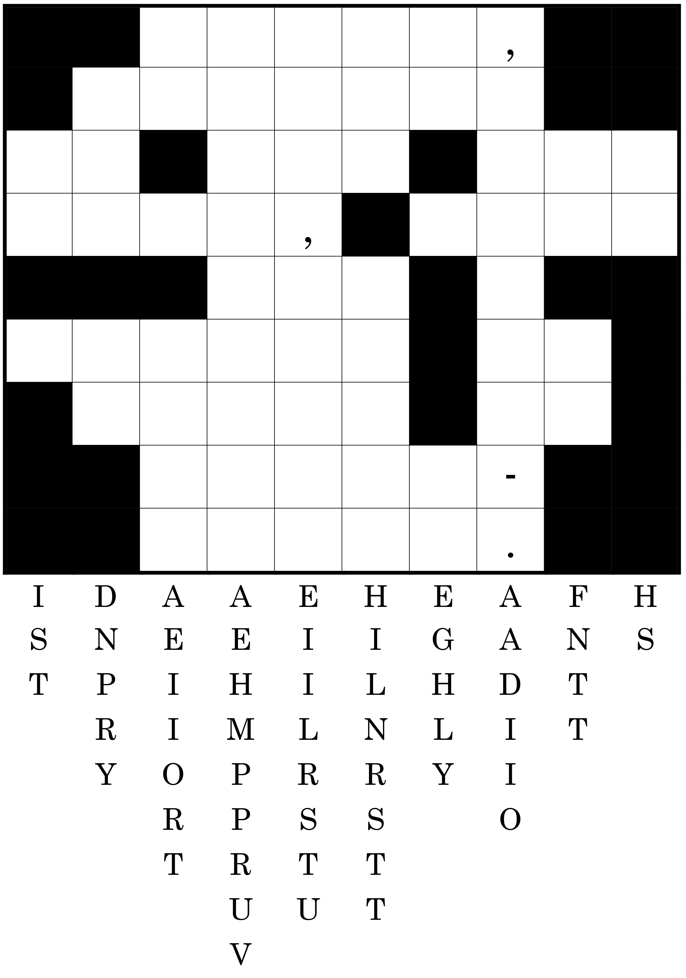

*April, dressed in all its trim, hath put a spirit of youth in everything. ~ William Shakespeare*

Get a Night Out at the Movies for 2 with my

**Referral Rewards Program**

As you probably know, advertising is very expensive. Instead of paying the newspaper or another place to advertise, we’d rather reward you. So, we’ve assembled the Referral Rewards Program.

Every time you refer someone who becomes a client, we will send you a gift certificate for two passes to the **Movies-8 Cinema.**

And Hey! What’s a movie without popcorn? The gift certificate will also cover a big box of hot, buttered popcorn and sodas!

**Welcome to our new and returning clients!**

Click on the text box and Insert names

**A gigantic THANK YOU to all who referred us last month…**

Insert names

About April, William Shakespeare said…

**Be sure to stop by to pick out and schedule   
your new floor installation, and   
from our families to yours have a great month!**

**Your Company Name**

123 Address, Someplace, ZZ 555555

555.555.5555 Phone ⚫ 555.555.5555 Fax

email@yourcompanyname.com

**YourCompanyWebsite.com**