

Reliable news for healthy living, saving money, and having fun!

****

**March 10:**

Daylight Saving Time (Spring Forward!)

**March 17:**

St. Patrick’s Day

**March 20:**

March (Spring) Equinox

Month at a Glance!

March 2019

**Jimbo’s Floors**

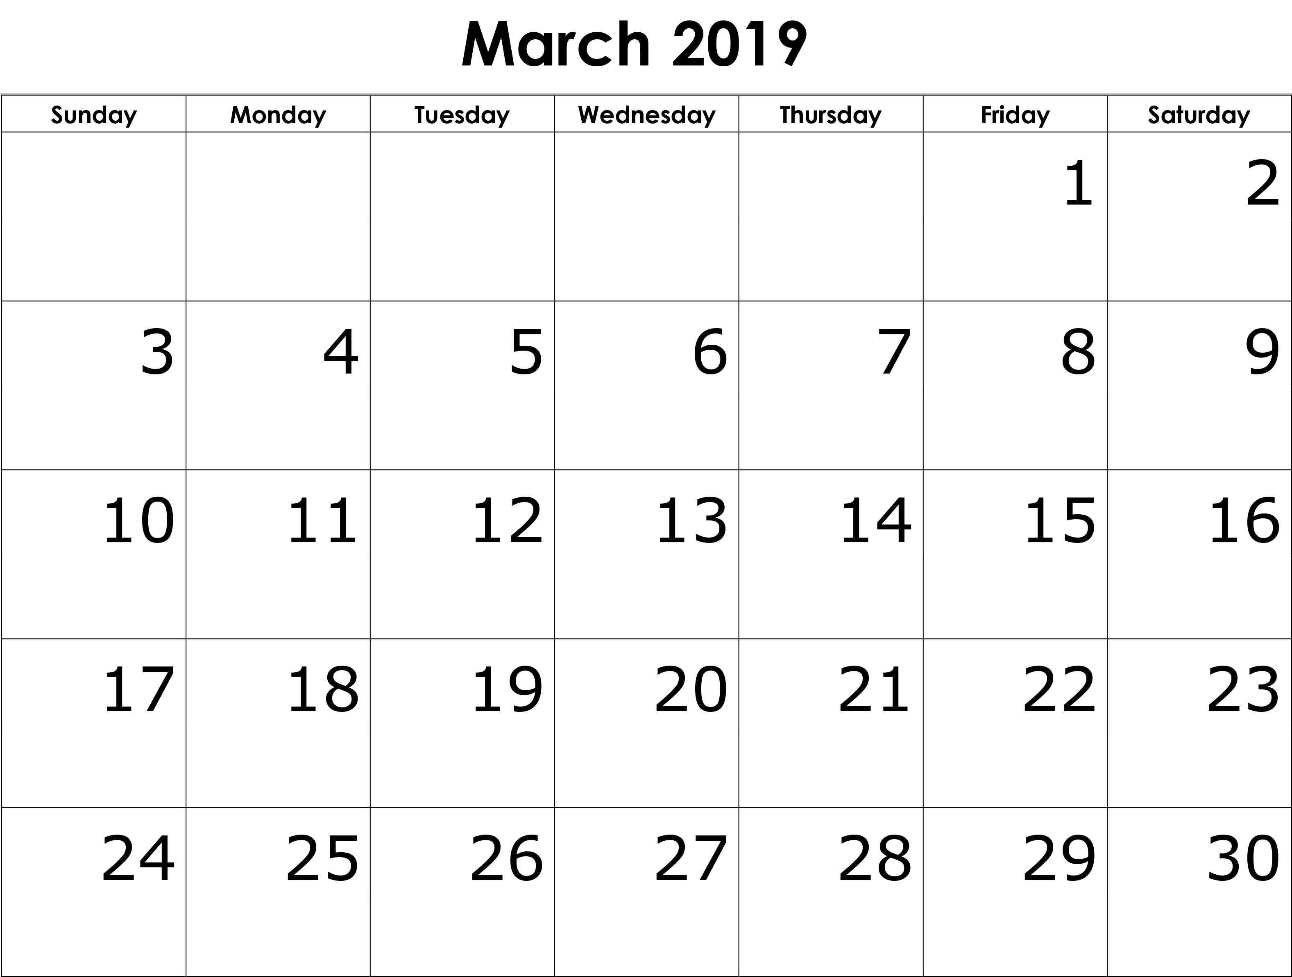

Suzie Smith!

You are this month’s   
Mystery Winner!

We have a   
**$10.00 Starbucks   
gift card**   
reserved just for you!

Come by our store to   
claim your prize!

Inside This Issue…

* Are you this month’s Mystery Winner?
* Month at a Glance
* Reasons Why You Aren't Sleeping Like A Baby
* Mega Trivia Contest
* Did you Know
* Second is Best When First is Plain!
* Thank you for the Kind Words
* Client of the Month
* The Ides of March

Dear Friends,

Your personal message goes here.

The personal message is important because it allows you to connect in a very personal way with your clients. This personal connection is sorely lacking in most businesses. Topic ideas:

Your hobbies

Something interesting happening this month. Wish them “Merry Christmas” or “Happy Thanksgiving.”

A thought from your heart

Appreciation for your clients and their referrals. Remind them that you will bend over backwards to provide their referrals with World Class Service.

Mention that month’s “special offer” insert

Your Friend,

Your Signature

Your Name

Scan to see our website

*“You’ll love your new floors, or I’ll replace them free!”*

~Jim Armstrong & Mick  
[www.JimbosFloors.com](http://www.JimbosFloors.com)



**When you buy floors**

**from us, you are**

**protected by our Installer Professionalism guarantee!** It’s part of Jimbo’s Floors 100% Iron-Clad Triple Guarantee.

Our installers are neat, clean, well-groomed, well-spoken and professional. They are trained and certified. They are guests in your home and they conduct themselves as such. They respect your home by using wall and corner guards, shoe covers and drop cloths.

You’ll receive the highest-quality installation in the business. And after they’re finished, they will leave your home as neat and clean as when they arrived!



After a full night’s sleep, we expect to wake refreshed and rejuvenated. Have you ever awakened feeling like you never slept at all, even when you cannot recall waking in the night?

Here are a few reasons you may feel tired, even after a full night’s sleep.

Technology

Our electronics are a form of interference. When we view the blue light before bed, it prevents the body from producing sleep-inducing melatonin. If you struggle with a restless night sleep or insomnia, consider not viewing those digital devices for a minimum of one hour before bed.

Other electronic devices that researchers discovered may cause poor sleep are fitness trackers. Some people who wear them to bed obsess over sleep stats so much that their anxiety level increases. That interferes with sleep.

For quality sleep consider getting technology away from the bed.

The bedroom

Speaking of bed, the environment we sleep in strongly impacts our quality of sleep. If your room is too bright or warm, getting blackout drapes and lowering the temperature can help.

If your bed is not comfortable because of the bedding, mattress, pets etc., improve the quality of your Z’s by making changes.

A quick evaluation of your environment may really pay off.

Inconsistency

An inconsistent bedtime is confusing to the body and brain. That fluctuating sleep time can make it difficult to fall asleep and stay that way through the night. Consider establishing a consistent bedtime, give or take a half-hour.

Another interference between you and quality sleep is coffee. Late day consumption can block the brain from finding a state of rest.

There are also medical conditions that can interfere with sleep, so if getting a good night’s rest is a persistent struggle, visit your physician to rule out health concerns.

Which two body parts keep growing throughout your lifetime?

A) eyes and toes B) nose and ears

C) liver and fingers D) arms and ankles

To enter, go to [www.JimbosFloors.com](http://www.JimbosFloors.com) and click on “Mega Trivia Contest.” Take your best guess…your chances of winning are better than you think!

(NOTE: see the NA instructions for this month if you don’t have the Jim Armstrong Marketing Website to direct them to.)

### Who Else Wants to Win

### Dinner for Two

### at the City Café!

### Take our Trivia Challenge and *you could win too!*

This month’s Mega Trivia question:

**Answer to last month’s question: A) Barry Gibb**

Congratulations to last month’s winner: **Client Name**

Reasons Why You Aren't Sleeping Like A Baby



Second is Best When First is Plain!



Tea is the second most consumed drink in the world! First place? Water. Teas are also culturally unique. Many countries have developed their own distinct blends not found anywhere else.

The most common teas in North America - black, green, oolong, and white - start with the leaves of a versatile sub-tropical plant called Camellia sinensis. The way it gets processed determines the type of tea it becomes.

Brewing tea correctly is vital to get the best flavor. When brewed too long or at the wrong temp., tea can get bitter or overly astringent.

When making tea, put ideally-temperature, filtered water and a measured amount of tea into an infuser. See each tea below for details.

**White Tea** - This is unprocessed tea. Leaves are plucked and most often left to wither and dry. This tea is pale green or yellow with a delicate flavor and aroma. To brew, add 1.5 tsp of tea leaves to 8 ounces of water at 176°F/80°C and steep for 2-3-minutes.

**Green Tea** – Leaves get plucked, steamed or pan-fired, then rolled. After that, they get a final firing to dry completely. This tea is green or yellow and can range in flavor from toasty or grassy to fresh steamed greens. To brew, add 1 tsp of tea leaves to 8 ounces of water at 176°F/80°C and steep for 2-3-minutes.

**Oolong Tea** – These teas take hours to produce. Processing utilizes five steps, some repeatedly - plucking, withering, rolling, oxidizing, and firing. These teas have a soft, smooth astringency with rich floral or fruity flavors. To brew, add 1 tsp of tea leaves to 8 ounces of water at 194°F/90°C and steep for 3-4 minutes.

**Black Tea** – Within a day the leaves go through all five processing steps mentioned above but on a more linear, non-repeated path. These teas are dark brown and deep red with the most robust flavor. Plus, they are the most popular to make iced tea. To brew, add 1 tsp of tea leaves to 8 ounces of water at 212°F/100°C and steep for 3-4 minutes.

There are a variety of teas to choose from in each of the types above and others not mentioned here. Visiting a tea shop is an experience filled with flavor-filled options!

“My new laminate floors in my kitchen and dining room are beautiful. I was treated with respect and courtesy as a single woman raising a daughter. I genuinely felt that Jim Armstrong and his staff display concern for my flooring needs and were a guiding light for me. I recommend his service to anyone looking for a supportive, positive experience.”

~Marsha Avalos, School Teacher, Yuba City

“We Recently went to Jimbo’s Floors for new tile for our bathroom, and we’re thrilled with the results! This is our third time using Jimbo’s. Jim will never make you feel uncomfortable for asking questions and he’ll do anything in his power to accommodate your needs. When you do business with Jim and the staff at Jimbo’s Floors, you will be treated like royalty. Our experience was painless and very professional. Jim is not only our flooring expert, he’s a friend. That’s how he makes you feel.”

~Marvin and Sandy Moeller, owners of Sierra Landscaping, Yuba City

Congratulations to our client of the month,

**Susan Johnson!**

Susan is a 3rd time returning client, and she recently purchased new laminate for her kitchen and dining room. She always has a big smile on her face and is a lot of fun to work with. *Thanks, Susan!*

As always, our clients of the month receive **2 movie passes for Movies-8!**

*Watch for your name here in a coming month!*

Thank You for the Kind Words!



Answers:

*1. Calendar, 2. Midpoint, 3. Debts, 4. Fifteen, 5. Shakespeare, 6. Caesar, 7. Roman*

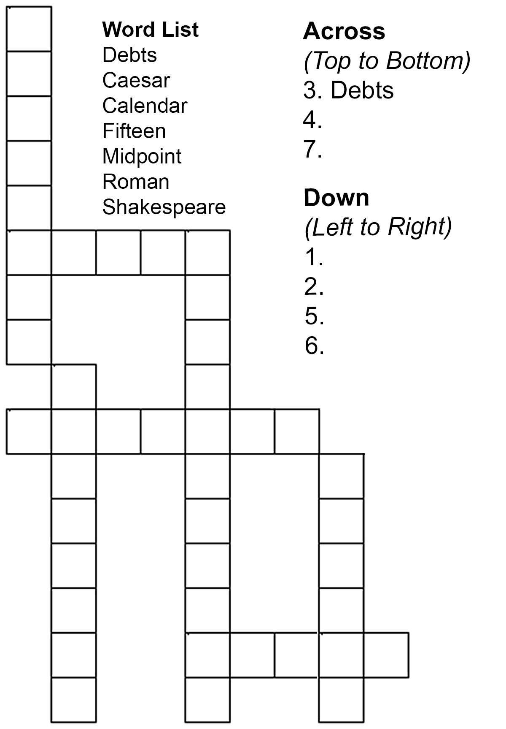

Get a Night Out at the Movies for 2 with my

**Referral Rewards Program**

As you probably know, advertising is very expensive. Instead of paying the newspaper or another place to advertise, we’d rather reward you. So, we’ve assembled the Referral Rewards Program.

Every time you refer someone who becomes a client, we will send you a gift certificate for two passes to the **Movies-8 Cinema.**

And Hey! What’s a movie without popcorn? The gift certificate will also cover a big box of hot, buttered popcorn and sodas!

**Welcome to our new and returning clients!**

Click on the text box and Insert names

**A gigantic THANK YOU to all who referred us last month…**

Insert names

The Ides of March

**Be sure to stop by to pick out and schedule   
your new floor installation, and   
from our families to yours have a great month!**

**Your Company Name**

123 Address, Someplace, ZZ 555555

555.555.5555 Phone ⚫ 555.555.5555 Fax

email@yourcompanyname.com

**YourCompanyWebsite.com**