

Reliable news for healthy living, saving money, and having fun!



**December 21**

Winter Solstice

**December 24**

Christmas Eve

**December 25**

Christmas

**December 31**

New Year's Eve

December 2018

**Jimbo’s Floors**

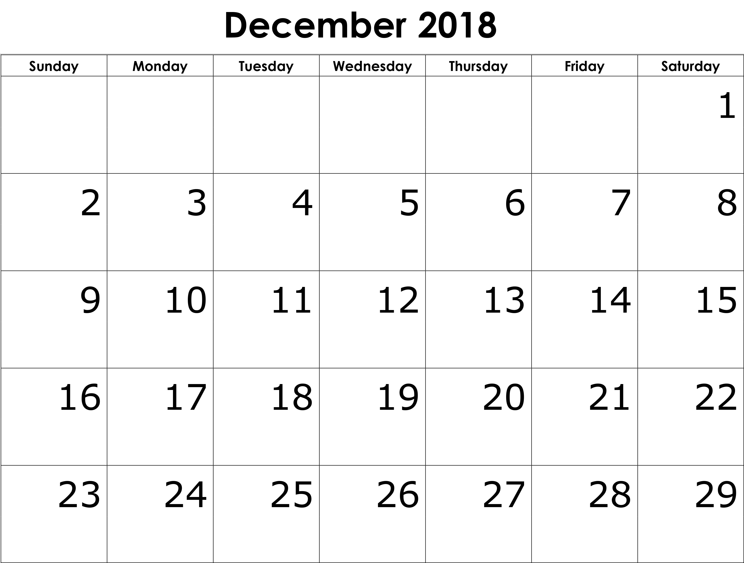

Suzie Smith!

You are this month’s   
Mystery Winner!

We have a   
**$10.00 Starbucks   
gift card**   
reserved just for you!

Come by our store to   
claim your prize!

Inside This Issue…

* Are you this month’s Mystery Winner?
* Month at a Glance
* Give yourself a bonus!
* Mega Trivia Contest
* Did you Know
* Happy Holiday Ideas
* Thank you for the Kind Words
* Client of the Month
* A Message for You!

Dear Friends,

Your personal message goes here.

The personal message is important because it allows you to connect in a very personal way with your clients. This personal connection is sorely lacking in most businesses. Topic ideas:

Your hobbies

Something interesting happening this month. Wish them “Merry Christmas” or “Happy Thanksgiving.”

A thought from your heart

Appreciation for your clients and their referrals. Remind them that you will bend over backwards to provide their referrals with World Class Service.

Mention that month’s “special offer” insert

Your Friend,

Your Signature

Your Name

Month at a Glance!

Scan to see our website

*“You’ll love your new floors, or I’ll replace them free!”*

~Jim Armstrong & Mick  
[www.JimbosFloors.com](http://www.JimbosFloors.com)



**We’d be happy to send you our electronic newsletter!**

The same combination of useful tips and offbeat stories you read here, but with these differences:

The e-Advisor will arrive in your email account once you give us permission

We send it once a week

The e-Advisor does not have the same content as the print Home Advisor – you’ll read all new stories, from helpful advice to items that give you a smile

Simply let us know which email account you’d like us to use for the e-Advisor.



Imagine looking at your bank account on December 31, 2019 and seeing $1,378 more sitting there for you! It’s a bonus to yourself because you saved a little each week throughout the year.

From saving a percentage of every income source to depositing a fixed amount every week of the year, ideas for saving money are plentiful, and the one that follows is not new. Maybe you’ve seen the *52-Week Savings Plan* on the Internet.

There are many reasons to save money. Financial advisors recommend saving money in a Survival Fund that is equal to three to six months of income. That is to cover expenses and day-to-day living in case an income source comes to an end.

Another recommendation is to save for emergencies and unexpected expenses. This covers thing like unanticipated medical expenses or home repairs that fall outside general maintenance.

A third consideration for savings is to cover anticipated costs that fall outside day-to-day expenses like regular home and car maintenance.

A fourth reason to save toward home renovations like new paint, tile and flooring, a new car, clothes, etc.

Of course, one of the favorite reasons to save is to go on vacation!

Wherever you choose to put your savings, getting an extra $1,378 from this *52-Week Savings Plan* is quite simple. Number the 52 weeks in 2019, then each week deposit into your savings account a dollar amount equivalent to the week number.

It looks like this:

The first week of January deposit $1 into your savings. During week 2, deposit $2, week 3, $3 … Keep going for all 52 weeks! In the last full week of 2019, your $52 deposit will bring the total saved to $1,378.

Now imagine what that savings would look like if you double or triple those weekly deposits! Or instead choose to deposit $52 per week for 52 weeks. This will give yourself a bonus savings of $2,704.

However you choose to save money in the new year, we hope you gain what is needed to exceed your goals!

What was the first year that the Rockefeller Center Christmas Tree was put up?

A) 1967 B) 1933

C) 1950 D) 1965

To enter, go to [www.JimbosFloors.com](http://www.JimbosFloors.com) and click on “Mega Trivia Contest.” Take your best guess…your chances of winning are better than you think!

(NOTE: see the HA instructions for this month if you don’t have the Jim Armstrong Marketing Website to direct them to.)

### Who Else Wants to Win

### Dinner for Two

### at the City Café!

### Take our Trivia Challenge and *you could win too!*

This month’s Mega Trivia question:

**Answer to last month’s question: A) Lake Superior**

Congratulations to last month’s winner: **Client Name**

Give yourself a bonus!



**Gingerbread house party** –Bring together the whole family along with all the gingerbread, frosting and colorful candy you can get your hands on.

If you have a large family, you can make more than one and make a competition out of it.

*Ahh December*. The time of year we anticipate family from far and wide to come for their annual visit. Keeping family with a range of ages and interests entertained during their visit may seem daunting! Keeping activities and conversations civil and neutral during this time may feel darn near impossible. Here are some suggestions to help keep things holiday-centered this year.

**Holiday lights tour** – First provide every member of the group a small note pad and pen. Next drive or walk the best neighborhood in your town for holiday lights. Have everyone in your group rate each display from 1 – 10, 10 being the best. Make sure to have a common way to track which house you’re voting on (house numbers work best). After the tour, return home and tally up the votes.

The winner gets the spoils from your *Gingerbread house party!*

You get bonus points if you take the winning (most beautiful) gingerbread house as a gift to the winner of the *Holiday lights tour.*

**Write letters to Santa** – Encourage adults and kids alike to write a letter to Santa asking for their most desired ‘thing’ in life and then make their case as to why they deserve it.

Anyone willing to read their letter out loud at your *Fancy Dinner Night* gets a special gift from the host!

**Fancy Dinner Night** – Most of us purchase clothes for holiday events. Why not wear them for your family dinner one night and watch the fancy dress instantly level up the behavior during a potentially difficult time together.

The goal is to keep your time together focused on the holidays and minimize opportunities for confrontation.

From our family to yours, happy holidays!

4 Activities to keep your holidays happy this year



“My new laminate floors in my kitchen and dining room are beautiful. I was treated with respect and courtesy as a single woman raising a daughter. I genuinely felt that Jim Armstrong and his staff display concern for my flooring needs and were a guiding light for me. I recommend his service to anyone looking for a supportive, positive experience.”

~Marsha Avalos, School Teacher, Yuba City

“We Recently went to Jimbo’s Floors for new tile for our bathroom, and we’re thrilled with the results! This is our third time using Jimbo’s. Jim will never make you feel uncomfortable for asking questions and he’ll do anything in his power to accommodate your needs. When you do business with Jim and the staff at Jimbo’s Floors, you will be treated like royalty. Our experience was painless and very professional. Jim is not only our flooring expert, he’s a friend. That’s how he makes you feel.”

~Marvin and Sandy Moeller, owners of Sierra Landscaping, Yuba City

Congratulations to our client of the month,

**Susan Johnson!**

Susan is a 3rd time returning client, and she recently purchased new laminate for her kitchen and dining room. She always has a big smile on her face and is a lot of fun to work with. *Thanks, Susan!*

As always, our clients of the month receive **2 movie passes for Movies-8!**

*Watch for your name here in a coming month!*

Thank You for the Kind Words!



Answers

Unscramble each of the clue words. Take the letters that appear in the shaded boxes and unscramble them for the final message.

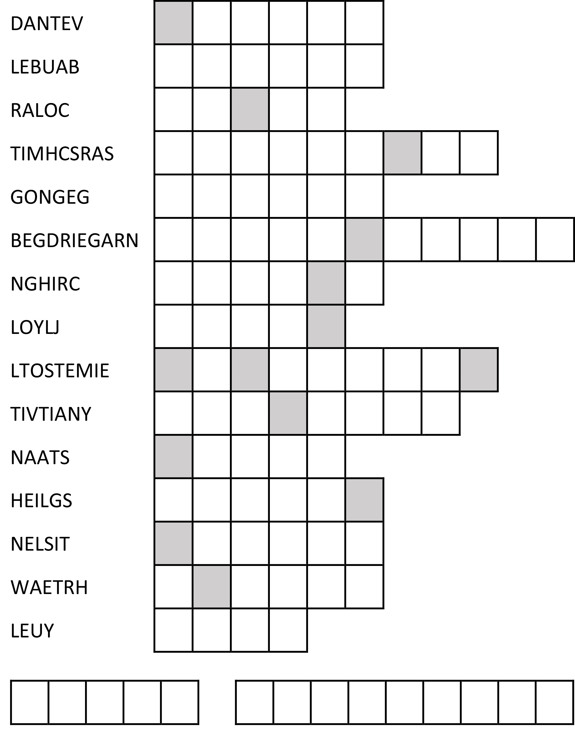

*Advent, Bauble, Carol, Christmas, Eggnog, Gingerbread, Grinch, Jolly, Mistletoe, Nativity, Santa, Sleigh, Tinsel, Wreath, Yule, Merry Christmas!*

Get a Night Out at the Movies for 2 with my

**Referral Rewards Program**

As you probably know, advertising is very expensive. Instead of paying the newspaper or another place to advertise, we’d rather reward you. So, we’ve assembled the Referral Rewards Program.

Every time you refer someone who becomes a client, we will send you a gift certificate for two passes to the **Movies-8 Cinema.**

And Hey! What’s a movie without popcorn? The gift certificate will also cover a big box of hot, buttered popcorn and sodas!

**Welcome to our new and returning clients!**

Click on the text box and Insert names

**A gigantic THANK YOU to all who referred us last month…**

Insert names

A Message for You!

**Be sure to stop by to pick out and schedule   
your new floor installation, and   
from our families to yours have a great month!**

**Your Company Name**

123 Address, Someplace, ZZ 555555

555.555.5555 Phone ⚫ 555.555.5555 Fax

email@yourcompanyname.com

**YourCompanyWebsite.com**