

Reliable news for healthy living, saving money, and having fun!



**January 1**

New Year's Day

**January 21**

Martin Luther King Jr. Day (USA)

January 2019

**Jimbo’s Floors**

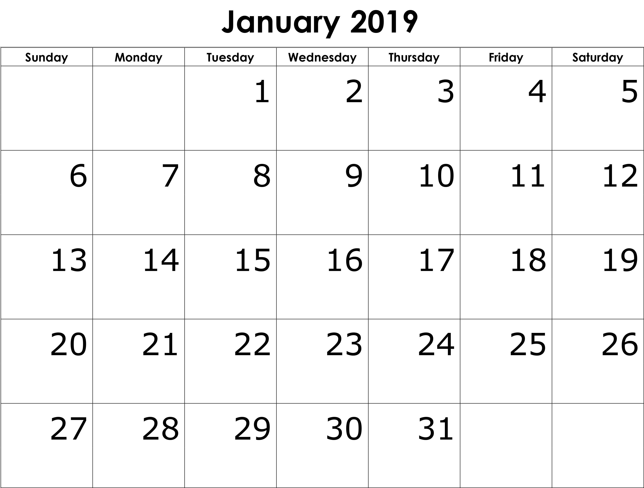

Suzie Smith!

You are this month’s   
Mystery Winner!

We have a   
**$10.00 Starbucks   
gift card**   
reserved just for you!

Come by our store to   
claim your prize!

Inside This Issue…

* Are you this month’s Mystery Winner?
* Month at a Glance
* Where Attention Goes Grows
* Mega Trivia Contest
* Did you Know
* Peculiar Words to Consider for 2019
* Thank you for the Kind Words
* Client of the Month
* May 2019 Be This Simple!

Dear Friends,

Your personal message goes here.

The personal message is important because it allows you to connect in a very personal way with your clients. This personal connection is sorely lacking in most businesses. Topic ideas:

Your hobbies

Something interesting happening this month. Wish them “Merry Christmas” or “Happy Thanksgiving.”

A thought from your heart

Appreciation for your clients and their referrals. Remind them that you will bend over backwards to provide their referrals with World Class Service.

Mention that month’s “special offer” insert

Your Friend,

Your Signature

Your Name

Month at a Glance!

Scan to see our website

*“You’ll love your new floors, or I’ll replace them free!”*

~Jim Armstrong & Mick  
[www.JimbosFloors.com](http://www.JimbosFloors.com)



***Our intention creates our reality.***

***~ Wayne Dyer***

Happy New Year!

**Are you a resolution setter?**

Many people take part in this New Year tradition, if only for a few weeks or months. At that point, nagging doubts about potential success take over.

Have you been there? Have you ever reached that place where “*Woohoo! Just like last year, old habits are here to stay!”*

Achieving success goes beyond wishing and hoping.

**Success requires intention.**

Intention is something to determine for each area of life - health, appearance, employment, finance, relationships …

**Be specific with your goals.**

Turn your intentions into goals. Write them down in present tense using positive language … "I am healthy and fit because I exercise daily." or "I have meaningful relationships with my family because I make time to be present with them each day."

Notice those goals express ideal qualities of life.

**Plan out actions and time.**

Write down actionable steps for each goal. If you encounter something you need to learn, write that down with the steps you will take to gain the knowledge. Plan your steps in order and schedule the time in your calendar.

**Read your goals every day.**

Reading your goals consistently helps keep them in focus (*Keep your eye on the ball*). It’s even more powerful to rewrite them out regularly. Some of the most successful people do this.

As you spend that time with a goal imagine what life is like when it’s your reality. Engage all the senses! How do you feel? How is your life different? What does it look like?

The more you expose yourself to that new reality the more powerful your goal, and that’s motivating!

**An added tip -** beware where you allow your focus to go because where your attention goes energy flows. Keep it on the goal.

**You are protected**

**by Jimbo’s Floors**

**“Zero Regrets Guarantee!”**

You’ll love your new floors, or I’ll replace them FREE!

If at any time during the first 30 days after installation you decide you don’t like your new flooring for whatever reason, just let me know. I’ll replace the materials free of charge. *(With an outrageously good guarantee like this, I can’t include the cost of installation, so you’ll have to cover that.)*

**It’s just part of Jimbo’s 100% Iron-Clad Triple Guarantee!**



Martin Luther King, Jr. was born Michael King Jr. on what date?

A) December 25, 1928 B) July 9, 1930

C) January 15, 1929 D) October 10, 1931

To enter, go to [www.JimbosFloors.com](http://www.JimbosFloors.com) and click on “Mega Trivia Contest.” Take your best guess…your chances of winning are better than you think!

(NOTE: see the NA instructions for this month if you don’t have the Jim Armstrong Marketing Website to direct them to.)

### Who Else Wants to Win

### Dinner for Two

### at the City Café!

### Take our Trivia Challenge and *you could win too!*

This month’s Mega Trivia question:

**Answer to last month’s question: B) 1933**

Congratulations to last month’s winner: **Client Name**

Where Attention Goes Energy Flows



People say the strangest things. Yet sometimes their quirky statements make a lot of sense! Ponder these words for 2019.

*“Always keep your words soft and sweet, just in case you have to eat them.”* – Andy Rooney

*“Age is a very high price to pay for maturity.”* – Tom Stoppard

*“When everything is coming your way, you’re in the wrong lane.”* - Unknown

*“Imagine what we would achieve if we had a spider’s determination.”* - Unknown

*“Live like you golf. Don’t forget to follow through.”* - Unknown

*“You must be the change you wish to see in the world.”* -Mahatma Gandhi

*“Courage is the power to let go of the familiar.”* - Raymond Lindquist

These frequently repeated phrases have the power shape our world as they sink in and resonance in different ways each time we hear them.

Many of us may have recognized these quotes, but you may just as easily remember expressions our parents used on a regular basis.

It can be great fun to share these familial epigrams with siblings and close friends when we get together.

Make it a goal this month to reach out to someone you know and tell them “*If you keep making that face, it’ll freeze that way*.”

Peculiar Words to Consider for 2019



Congratulations to our client of the month,

**Susan Johnson!**

Susan is a 3rd time returning client, and she recently purchased new laminate for her kitchen and dining room. She always has a big smile on her face and is a lot of fun to work with. *Thanks, Susan!*

As always, our clients of the month receive **2 movie passes for Movies-8!**

*Watch for your name here in a coming month!*

Thank You for the Kind Words!

“My new laminate floors in my kitchen and dining room are beautiful. I was treated with respect and courtesy as a single woman raising a daughter. I genuinely felt that Jim Armstrong and his staff display concern for my flooring needs and were a guiding light for me. I recommend his service to anyone looking for a supportive, positive experience.”

~Marsha Avalos, School Teacher, Yuba City

“We Recently went to Jimbo’s Floors for new tile for our bathroom, and we’re thrilled with the results! This is our third time using Jimbo’s. Jim will never make you feel uncomfortable for asking questions and he’ll do anything in his power to accommodate your needs. When you do business with Jim and the staff at Jimbo’s Floors, you will be treated like royalty. Our experience was painless and very professional. Jim is not only our flooring expert, he’s a friend. That’s how he makes you feel.”

~Marvin and Sandy Moeller, owners of Sierra Landscaping, Yuba City





Get a Night Out at the Movies for 2 with my

**Referral Rewards Program**

As you probably know, advertising is very expensive. Instead of paying the newspaper or another place to advertise, we’d rather reward you. So, we’ve assembled the Referral Rewards Program.

Every time you refer someone who becomes a client, we will send you a gift certificate for two passes to the **Movies-8 Cinema.**

And Hey! What’s a movie without popcorn? The gift certificate will also cover a big box of hot, buttered popcorn and sodas!

**Welcome to our new and returning clients!**

Click on the text box and Insert names

**A gigantic THANK YOU to all who referred us last month…**

Insert names

May 2019 Be This Simple!

**Be sure to stop by to pick out and schedule   
your new floor installation, and   
from our families to yours have a great month!**

**Your Company Name**

123 Address, Someplace, ZZ 555555

555.555.5555 Phone ⚫ 555.555.5555 Fax

email@yourcompanyname.com

**YourCompanyWebsite.com**