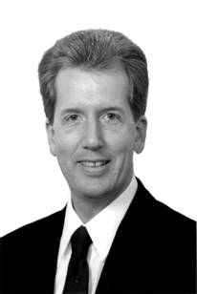

YOUR NAME
Owner of YOUR STORE

Dear CLIENT NAME,

Purchasing floor covering is like taking an airplane flight across the country. You have no idea how the trip will go when you first start out. The pilot doesn’t either! You could have 33 different types of turbulence, or your flight could go smoothly and land right on time. A good pilot will use his or her expertise to navigate around storms, but if they are honest with you, they know they can’t promise a turbulence-free flight. The pilot’s job is to get you to your destination in the shortest time possible, and keep you updated during the trip.

I have included a list of 33 types of turbulence that we could encounter during your installation process. This is not an exhaustive list, but it covers most of the common issues.

As your floor covering consultant, I see myself as the pilot of your plane. My job is to help you get your floor covering installed with the least amount of stress possible. I can’t guarantee that we won’t hit turbulence, but I promise to do my best to make it the smoothest flight possible. And if we do hit turbulence, I won’t bail out on you. I’m your teammate throughout the flight, and I’ll work hard to get you safely to your destination.

At your Service,

YOUR NAME
Owner of YOUR STORE
your store info

