Here’s An Offer That’s A
No-Brainer!!

I Can Show You How Get New Floors And
Do It So Easily That You’d Have To Be “Out Of Your Mind”
Not To Visit Jimbo’s Floors!

Dear Friend & Client,

Why did I send you a small brain in this letter?

First, to draw your attention to this short message.
Second, I know what its like to have a ‘sure-thing’ staring you in the face; a “No-Brainer.” I’ve been there. I’ve passed up on other opportunities or advice. When I’ve looked back I wish I had taken it.

Here’s An Offer That Will “Blow Your Mind!”
Get 17.3% More FREE!

Bring this letter to Jimbo’s Floors by <<Date 30 days in the future>> and you’ll get 17.3% more flooring FREE on top of whatever you purchase! This applies to all types of floor, including wood, laminate, carpet, ceramic tile, vinyl, stone….everything offered at Jimbo’s!
“What Was I Thinking??”
My accountant—Stanley Pennyfingers—Says I must have lost my brains to make an offer like this. That we can’t afford it. That we’ll go broke!

Oh well…call me crazy! But you’d better hurry and take advantage of this amazing special before Pennyfingers talks me out of it and I change my ‘mind.’

5 Reasons You’ll Have Peace Of “Mind”
With Jimbo’s Floors

You are protected by my “Zero Regrets Guarantee.” You’ll love your new floors or I’ll replace them FREE in the first 30 days!

I’ll give you a FREE lifetime installation warranty on any floor you buy!

I only hire courteous, clean-cut, professional installers who are thoroughly trained and certified.


I have a thick book of testimonials from past clients. Have a look through it when you visit. We keep it right on the front counter!
We’ll put your “mind” at ease and a smile on your face!

Do You Have Anyone In “Mind” Who Needs New Flooring

Who do you know that is looking to purchase new floors? Can I count on you to “Think” of us and pass this letter along to them? You will be doing them a tremendous favor by referring them to a professional floor dealer they can trust. AND…don’t forget about my Referral Reward Program. If you refer someone who purchases floors during the month of March, I’ll send you and a guest out to dinner at the Rusty Duck!

Sincerely,


Jim Armstrong

Take advantage of the Jimbo’s Floors “No Brainer” offer! Get 17.3% more FREE! But this “Mind Blowing” offer expires <<Deadline>>!

Read What Others “Think” About Jimbo’s Floors!

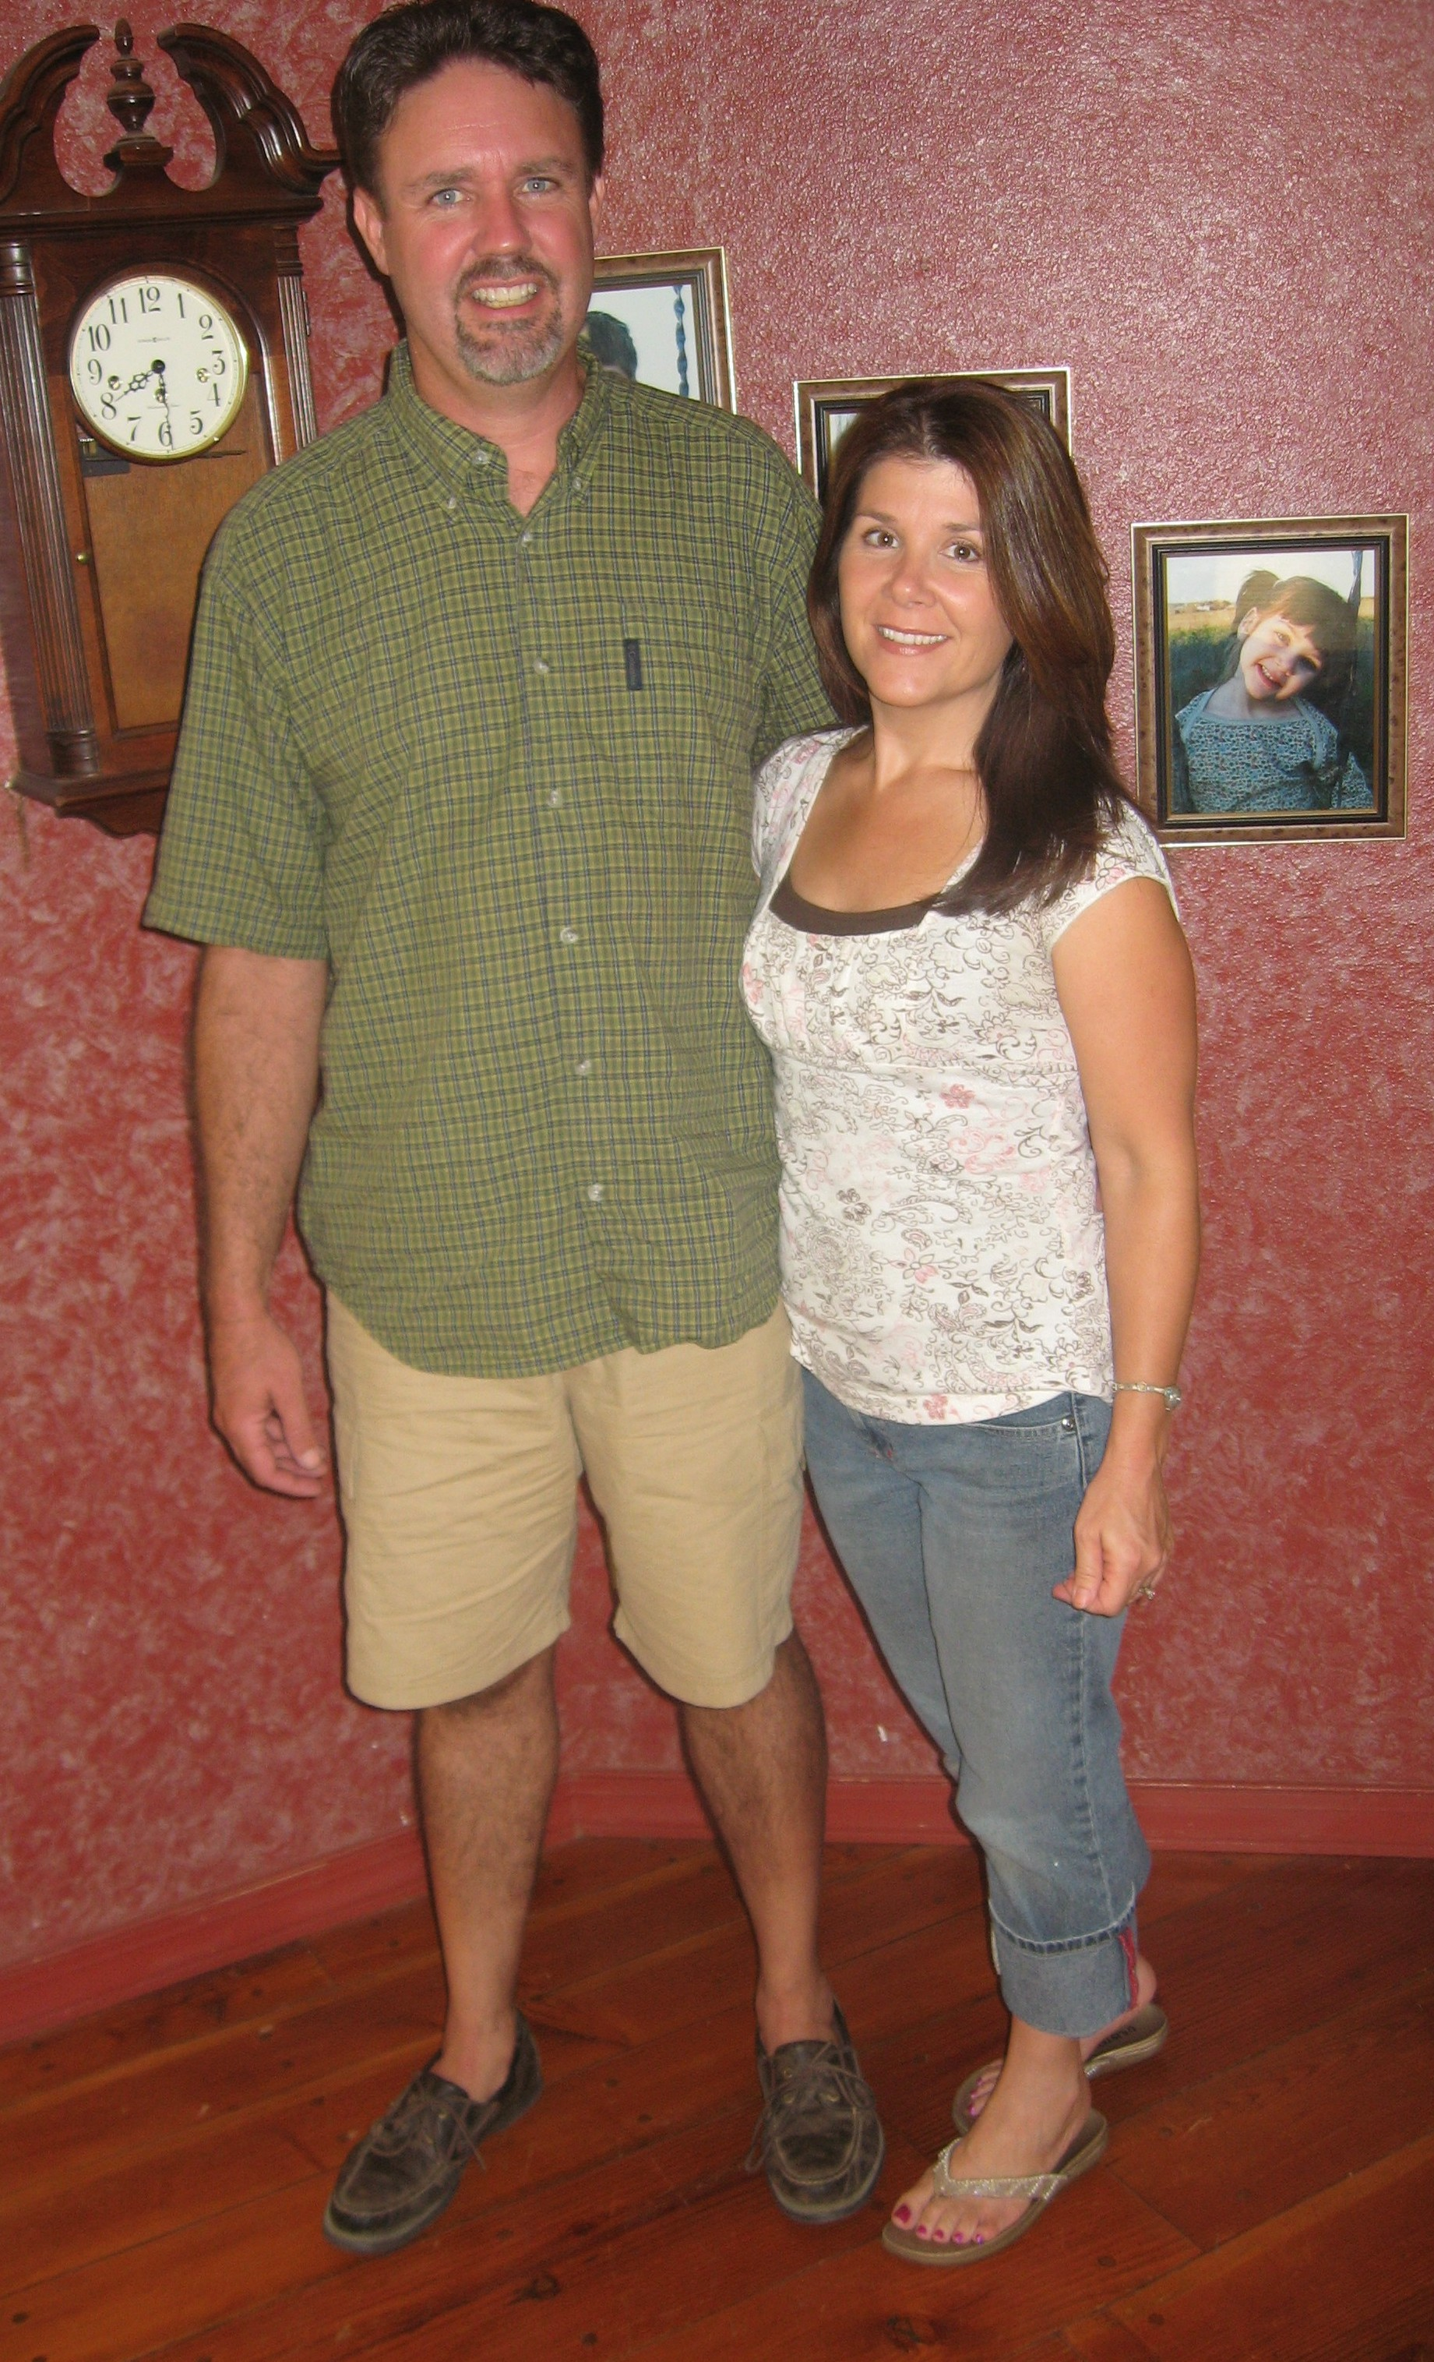
“This is our 2nd flooring purchase thru Jimbo’s Floors and once again it was painless! Thank you for your great service and we have highly recommended your services to other people. On a scale of 1-10, with a 10 being the best, we would rate the courtesy of your staff as a 10. Thanks again for the beautiful carpets!”

“Jim, I just received the surprise package you mailed and want to thank you for it. It will be used, believe me! If I don't use it myself, I have three kids who will enjoy the candy and popcorn! The movie will definitely be mine--although I may share it with them (their TV, you know!) Also, a big thank you to both you and Sheryl for getting my floors done in time for Thanksgiving. I really doubted it could be done. But you both proved me wrong and I appreciate it! I'll be happy to recommend you to anyone who may need your help in the future. Thanks again!
“P.S. Everyone raved about the new hard wood!”
-Janet Narducci, Home Maker, Gridley
-Chad & Michelle Lamar, owners of A better Look hair salon, Yuba City

“Jim… if anyone asks me about flooring I will certainly give them your name! You provided me with a painless process. After our initial meeting, I found the opportunity to work with you and Sheryl via continued emails very pleasant. The timeliness of your responses was much appreciated. These emails helped you and Sheryl provide a degree of personalized service far superior to larger stores I have experience with. I felt in constant touch and never had any lingering questions while I was "in process". Highly recommended!”
-David Kuvelis, X-Ray Technician at Fremont/Rideout Health Group, Yuba City

“This is the 2nd time I’ve used Jimbo’s Floors and Roberto Gonzales. I contacted Roberto for floors when I was moving into a new home. He co-ordinated with the Realtor to make sure the floors were installed on time. When the purchase closed escrow, I was able to begin moving my furniture in immediately, and my new carpets looked fabulantastic! Way to go Roberto!”
-Wayne Jens, Dentist, Yuba City

“Dear Roberto, we’d like to thank you for always being available to answer our many questions about the floor-buying process. Your availability and your expertise gave us the answers we needed to get flooring for our first home. Because this was our first time buying a home and new floors, we had many questions. Whether meeting face-to-face or speaking over the phone, we always felt you gave 100% of yourself to our needs. Thank you for helping us find what turned out to be beautiful laminate. The area rug you recommended looks great in the dining room. You’re the best.”
-Jonathan & Marie Lavenan, Software Sales and Paralegal, Marysville

