Not sure whether to clean or replace your carpet???
Then take advantage of the CLEANWAY / FLOORING AMERICA…
“Clean Or Replace Warranty!”

I know you want to improve the rentability of your property and the satisfaction of your tenants, that’s why we have this incredible offer!

Dear Friend & Client,

Hi, I’m Pat Thomas, and I specialize in knocking the socks off my clients with The Most Thorough Carpet Cleaning they have ever had. I understand that you may be unhappy with the condition of the carpets in one or more of your properties. Your tenants may feel the same way and I want to change that! How can I do such a thing? With my…

“Clean Or Replace Warranty!”

Does this sound familiar…?

The carpet in one or more of your properties is badly soiled and you’re not sure whether you should clean or replace them. You know the ease of renting the property will increase significantly and your tenants will be happier if carpeting is in good condition. You would really like to try cleaning them first but you don’t want to throw away your money if they ultimately have to be replaced.

I know how you feel! And that’s why I partnered with Dan Ginnaty, Jerry Traxinger and Rose Sheldon of the Great Falls FLOORING AMERICA to create our “Clean or Replace Warranty.”

Here’s how it works: I’ll give your carpets the most thorough cleaning they’ve ever had. Then in the next 30 days if you decide to replace them we’ll apply the ENTIRE cost of cleaning towards the purchase of new floors at the Great Falls FLOORING AMERICA!

We will always leave you with the best possible cleaning results! You simply cannot lose with our Zero Risk “Clean or Replace Warranty”

Also…any friend of yours is a friend of mine. You can pass this letter along to a friend or relative who needs Carpet Cleaning, too. I’ll extend this same offer to them. You will be doing them a gigantic favor by referring them to a cleaning company they can trust.

There’s MORE! You Are Protected By My 100% Iron-Clad, Bullet-Proof “No Regrets Guarantee”… You Get The Most Thorough Cleaning You’ve Ever Seen Or Its FREE!

A big concern when investing in Carpet Cleaning is accidentally choosing the wrong cleaning company. Then having to live with a decision you’ll regret. I’ve TOTALLY eliminated that concern for my clients. If at any time during the first 7 days after the Carpet Cleaning you decide you don’t like the results for whatever reason, just let me know. I’ll re-clean the carpet FREE of charge.
Turn the page for more!

If you called any other carpet cleaning service and asked them for a guarantee like this, they will probably laugh and tell you “no way!” So how can I offer such a powerful guarantee? I couldn’t unless I was absolutely confident in the quality of my service. I am confident, and you will be too…I guarantee it!

Here’s How My Cleaning Service Will Totally “Knock Your Socks Off!”

- The Most Thorough Cleaning you’ve Ever Seen or It’s Free. If you don’t feel that this is the most thorough cleaning you’ve ever seen I will re-clean you’re carpet at No Charge. If you are still not pleased for any reason I’ll refund your money and we will part friends.
- No spots should ever return. If it does within 7 days after cleaning we will return.
- We use extra care when moving or working around your furniture.
- I pay special attention to cleaning along edges, in corners and behind doors.
- Our cleaning system extracts using high temperature, high pressure van mounted cleaning system to remove soil, stains, bacteria, fungus, pet dander, dust mites and other allergens that may be lurking in your carpet.
- Final grooming with a special brush to lift the fibers and restore the nap.

What to do right now—Call CleanWay Carpet Care NOW to schedule your cleaning appointment. Plus take advantage of all the other powerful benefits you will enjoy as my personal client. I’m looking forward to helping you maximize the value of your property with the Carpet Cleaning of your dreams! (You can call me at 406-452-1500 and speak to me directly.)

Don’t Delay Call NOW!
Dan, Rose and Jerry


452-1500 voice 453-3444 fax
1209 15th St. No.
Great Falls, MT 59401
cleanwaycc@gmail.com
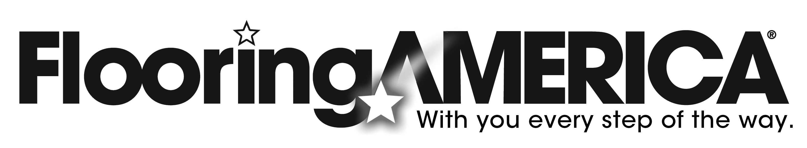 727-8000
1209 15th St. No.
Great Falls, MT 59401
www.flooringamericagf.com
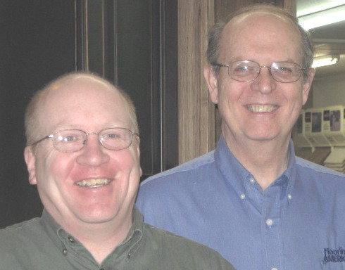
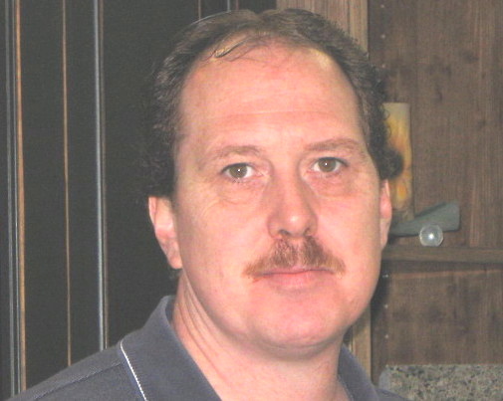

Pat Thomas

